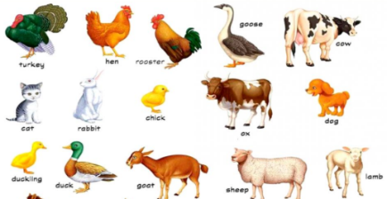
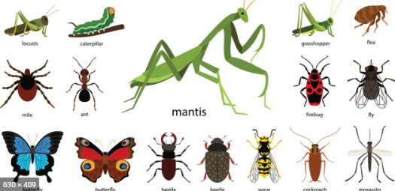
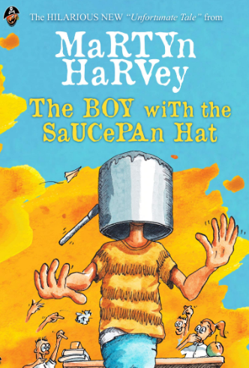
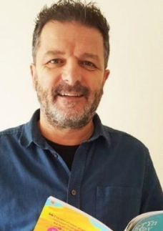
Writing Challenge
With Martyn Harvey

Theme: Fauna
Deadline: Friday 12th June
Having listened to fantastic poetry every day this week, your challenge is to: write your own poem!
The theme is ‘fauna’, which means animal. The poems Martyn has given us this week are all based on this theme to help you develop your own; yours could be a creature great or small.
There is no minimum/maximum length or style for your poem, but Martyn and I will be looking out for creativity, language choices and one which makes us laugh!
Please send your entries to Miss Rees-Boughton or bring them into school!
We wish you the very best of luck!
Send your entries to:
alice.rees-boughton@ramsgateartsprimaryschool.co.uk

