g or kg |  | mm, cm or m |  | ml or L
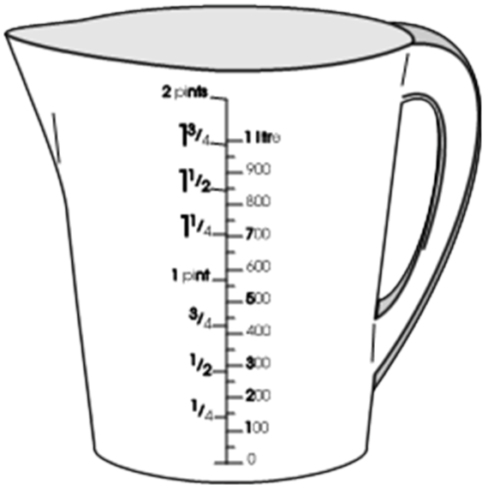 |  | 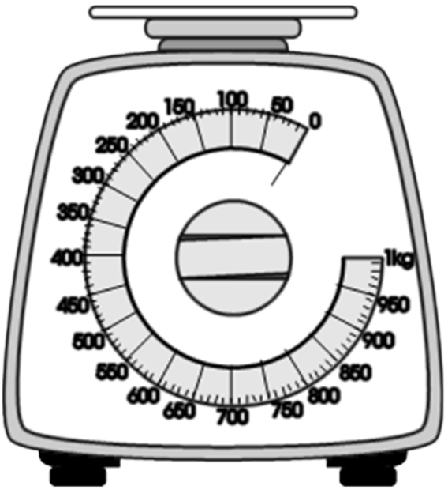 |  | 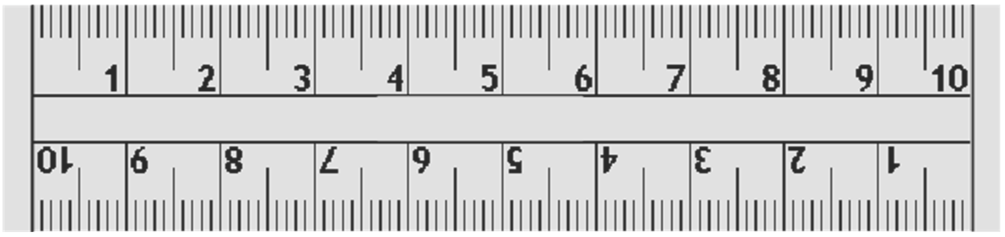
Length |  | Volume /  Capacity |  | Weight
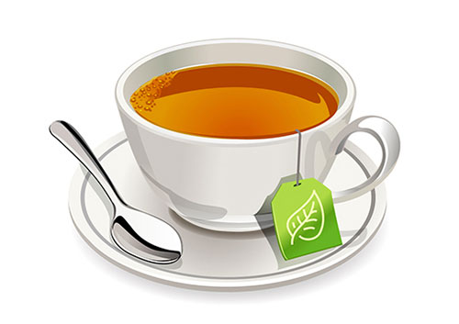  The amount of tea in a cup. |  | 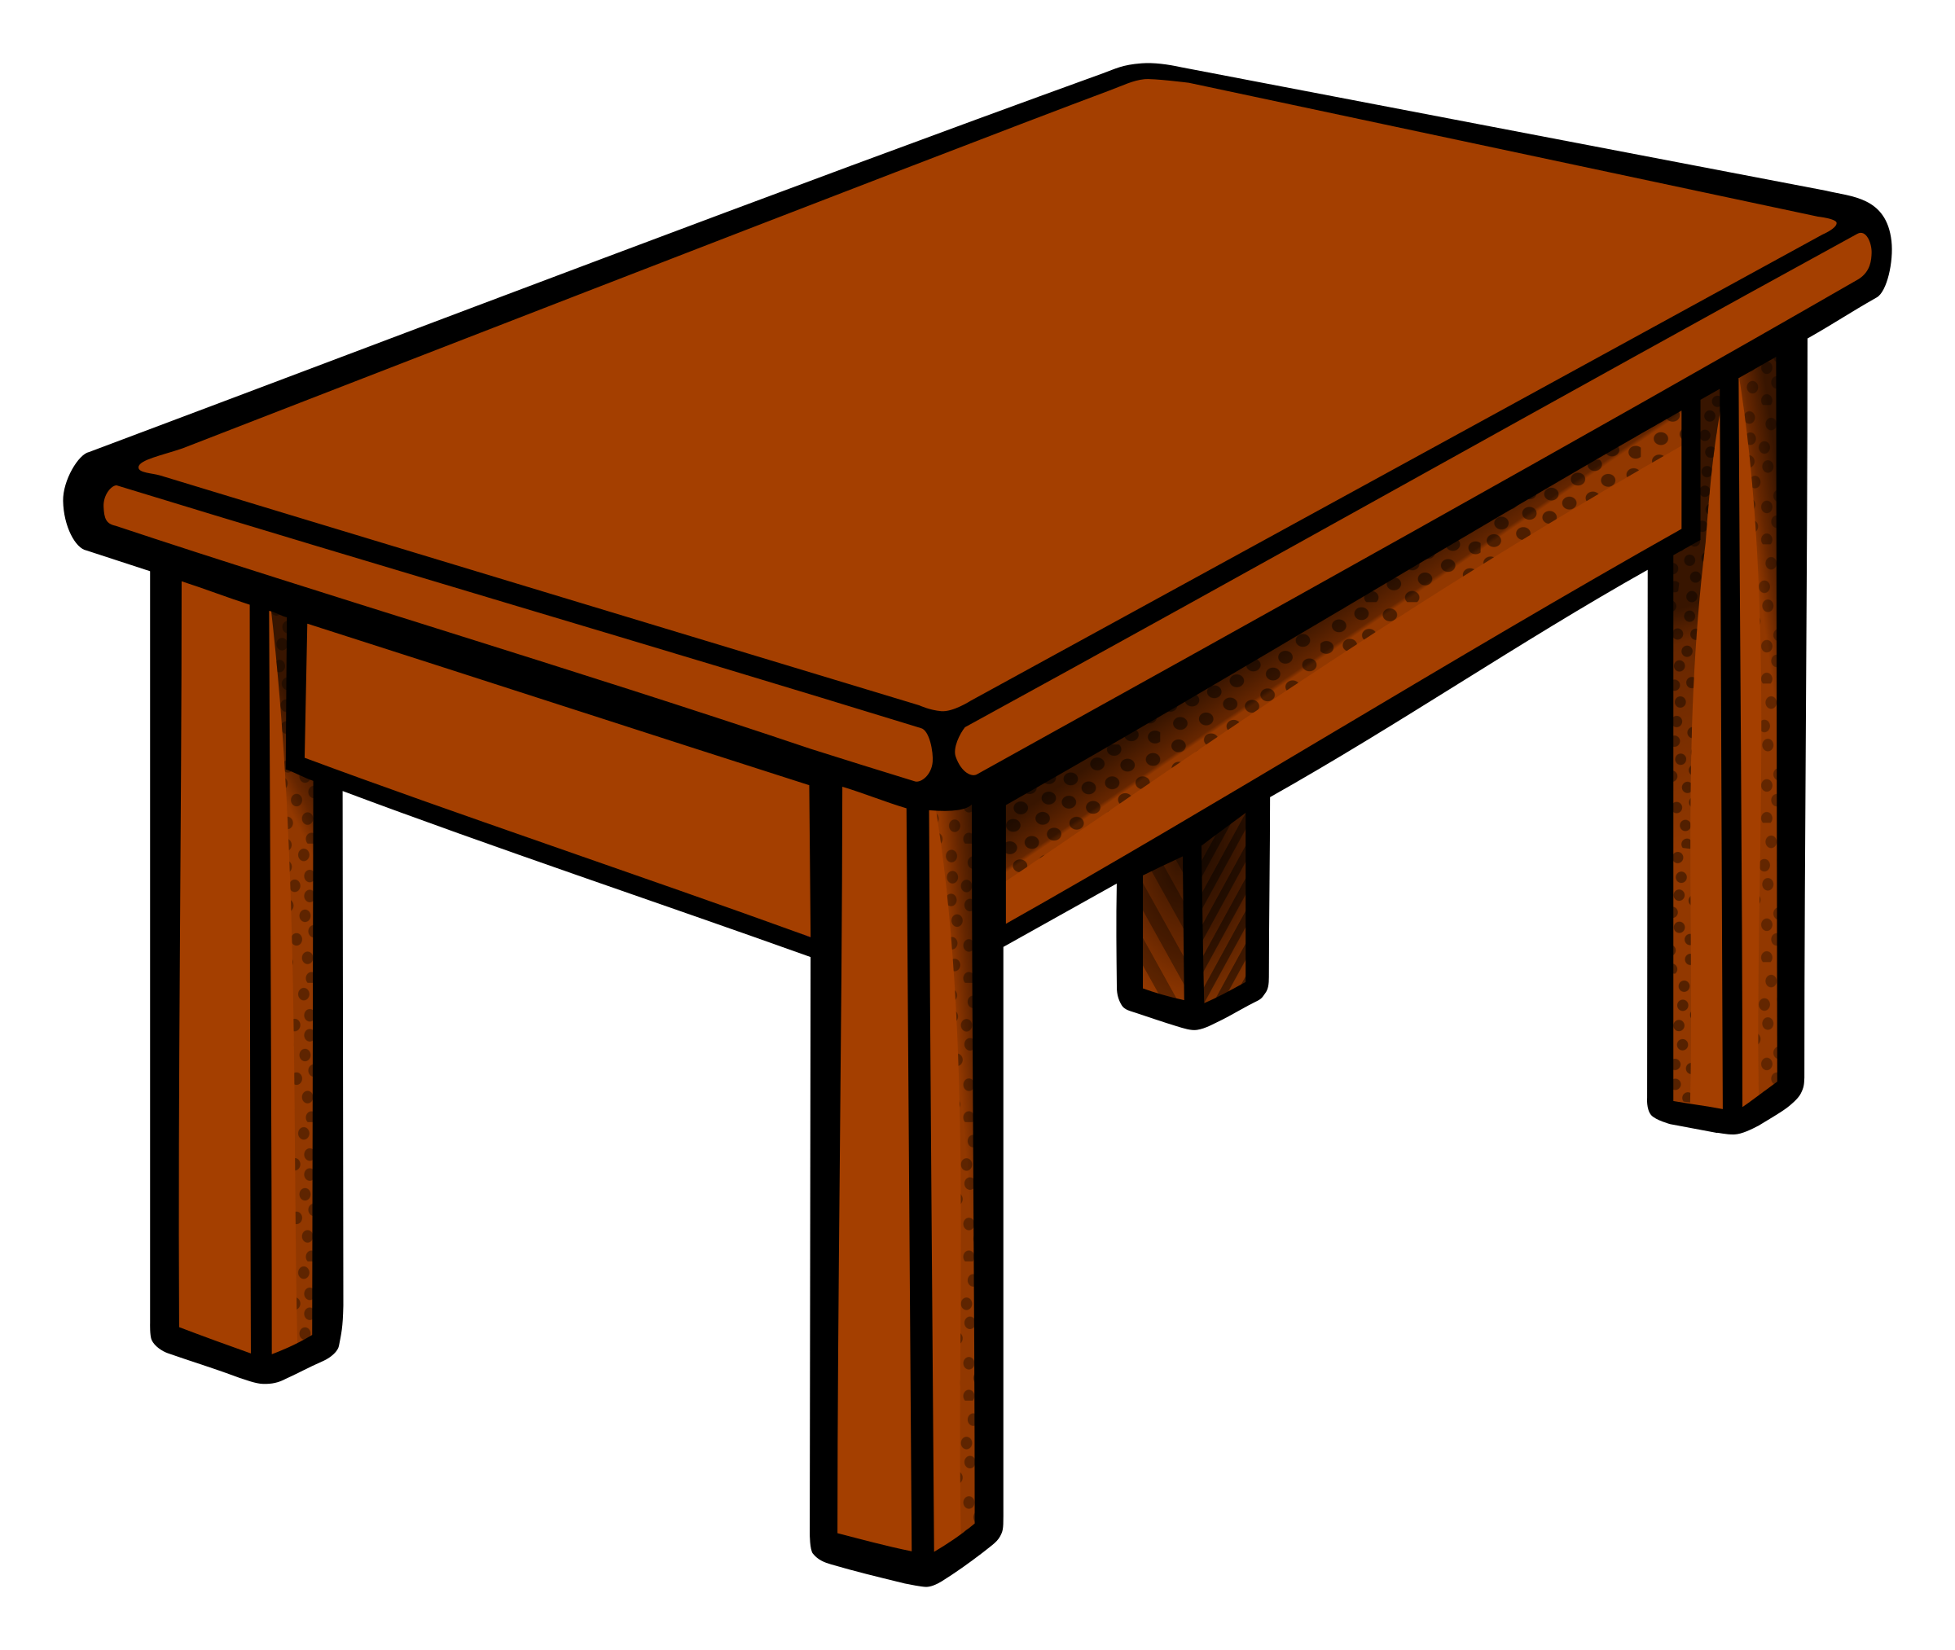  The height of the table. |  | 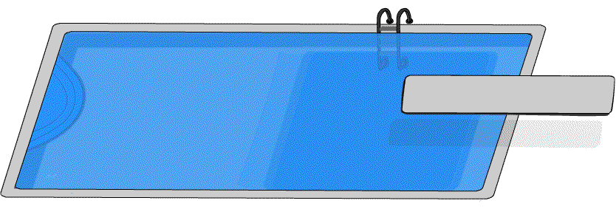  Distance from one end to the other of a swimming pool.
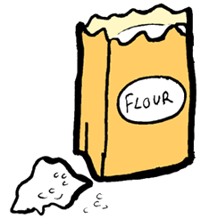  The weight of flour needed to bake a cake. |  | 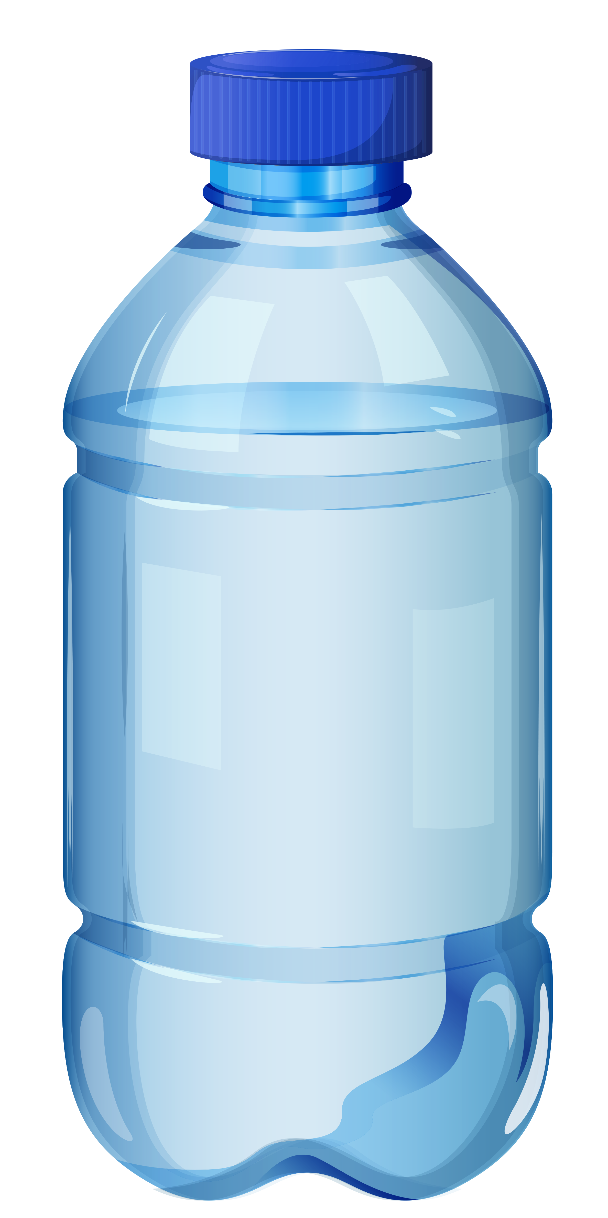  The quantity of water in my bottle. |  | 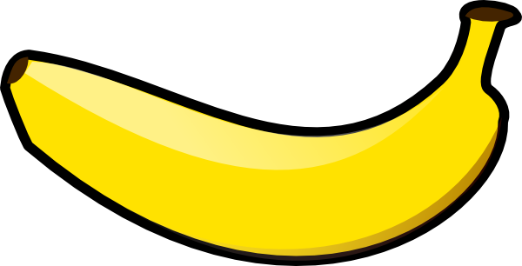  How heavy the banana is.
How long the banana is. |  | 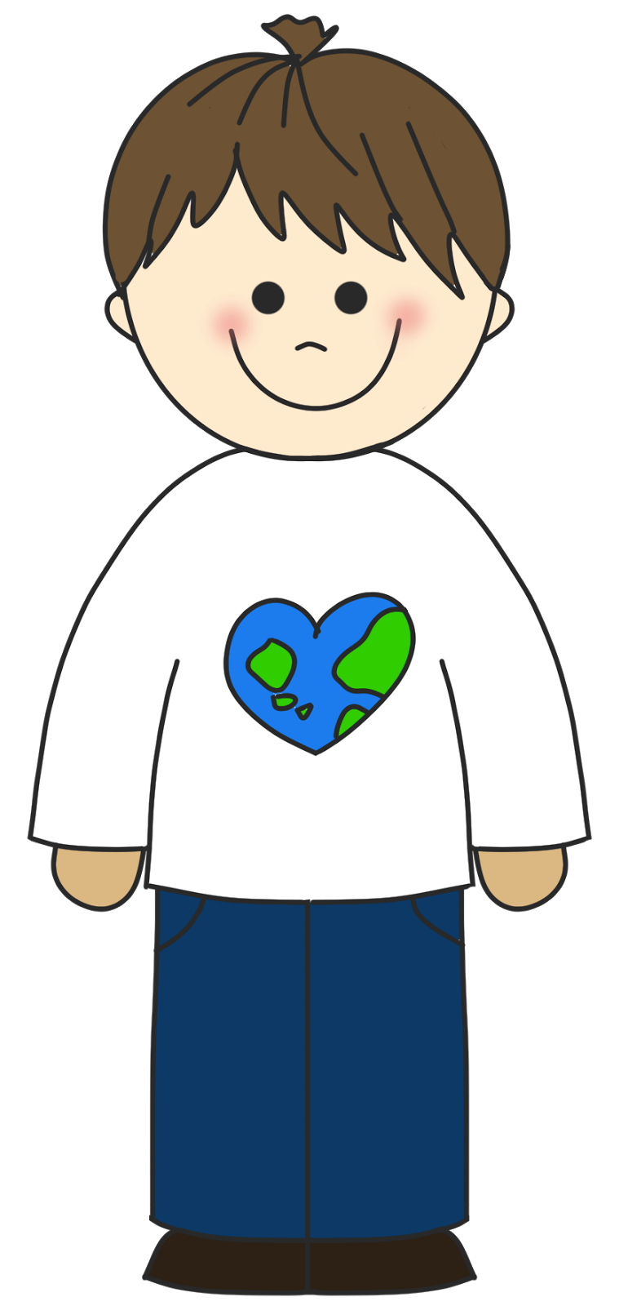  How much the boy weighs. |  | 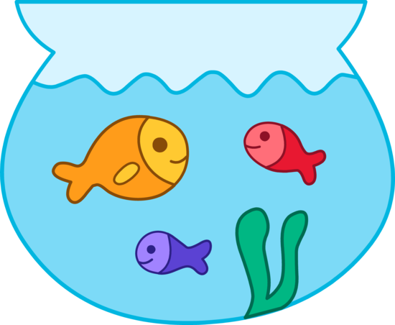  The amount of water the fish bowl holds.

