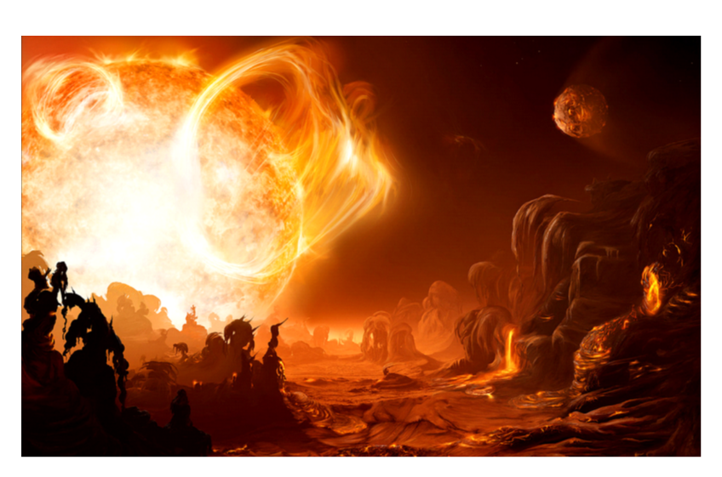

Suffering the fury of a dying sun, the rock of the planet below had melted into a soup of slowly moving brown liquid. Huge globes of melted rock were being dragged from the surface of the planet and into the fiery bowels of the blazing star above. The smell of sulphur, fire and brimstone permeated the hell-like atmosphere. Slowly, inescapably, the dying planet was spiralling into oblivion. There was no escape.

