The Mystery of the Missing Macaws at Maythorpe Zoo
The pupils of Appleby Academy are very excited to be going on their school trip to Maythorpe Zoo. They have been learning about animals in class and they are thrilled to finally be going to see the chimpanzees, zebras, tigers, meerkats and many more wonderful animals!
They know which groups they are in, they know who their group leader is and they have everything they need.
They get on the coach, squabble over the back seat and soon they are off, singing ‘The Wheels on the Bus’ at the tops of their voices.
When they arrive, they leave their bags in a great big tub and are led away to see the first group of animals. The trip is going swimmingly, with everyone having a ‘whale’ of a time.
However, disaster has struck! Someone has opened the door to the macaw enclosure and all the birds have flown into the nearby trees!
Your task is to use the descriptions of the suspects and solve the clues to discover who caused chaos with the missing macaws.

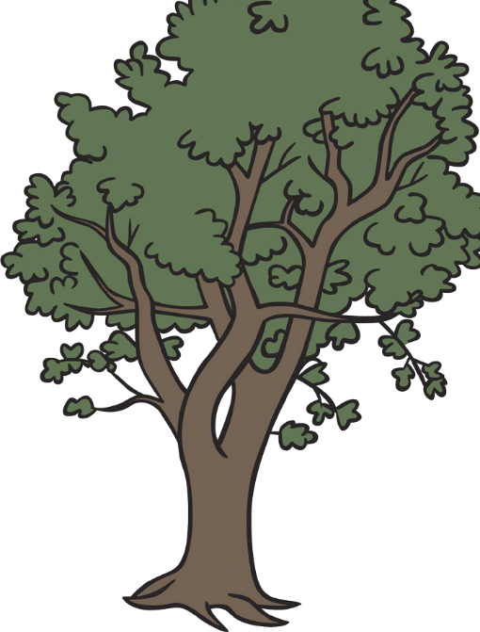
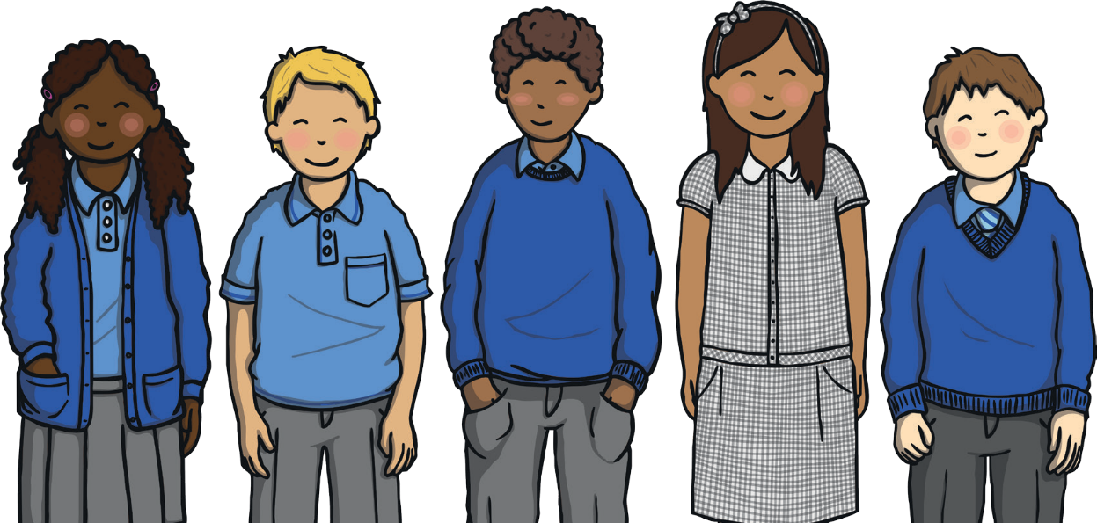


Name | M/F | Height | Bought Birdseed | Favourite Animal | Type of Fruit in Lunchbox
Alina | F | tall | yes | zebras | melon
Beau | M | short | no | chimps | banana
Callum | M | tall | no | chimps | apple
Daisy | F | tall | yes | zebras | apricot
Ellis | M | short | no | tigers | banana
Fiza | F | tall | no | snakes | apple
Grace | F | tall | yes | chimps | apricot
Harvey | M | short | no | zebras | melon
Ismael | M | tall | yes | chimps | apricot
James | M | short | yes | chimps | melon
Kristoph | M | tall | yes | tigers | banana
Lionel | M | tall | yes | tigers | apricot
Monika | F | short | no | snakes | apple
Neil | M | tall | yes | chimps | apple
Ollie | M | short | yes | tigers | melon
Parwinder | M | short | no | chimps | apricot
Quincy | M | tall | yes | zebras | melon
Ranjit | M | tall | yes | tigers | apple
Sara | F | tall | yes | chimps | melon
Tia | F | tall | yes | tigers | apricot

Work out the answers to these calculations and colour them in.
If most of the answers are even, then the culprit is tall. If most of the answers are odd, then the culprit is short.

12p + 24p | 50p - 30p | £1.20 - 30p
17p + 22p | 19p - 11p | 87p + 12p
46p + 6p | 13p + 20p | 29p + 4p
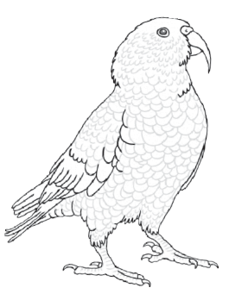


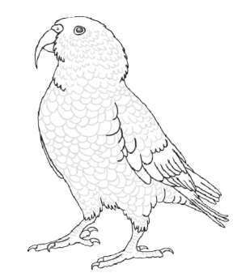








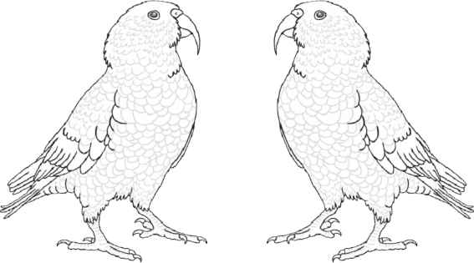





20p

25p
8p

99p

90p

71p

33p

13p

28p

52p
57p
18p

36p

39p

Tick one.
There are more odd answers so the culprit is short.
There are more even answers so the culprit is tall

