The naughty snakes are hiding the answers to these calculations.
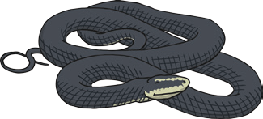
Solve these calculations. Then, find their inverse calculation in the table. Rearrange the words to make a sentence to solve the second clue.

15 + 3 = 27 - 3 =

51 + 11 = 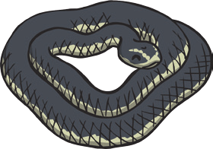
10 + 20 = 30  apricots | 45 - 31 = 14  female | 24 + 3 = 27  culprit
62 - 51 = 11  the | 27 - 4 = 23  chimps | 11 + 10 = 21  bird
45 - 15 = 30  male | 18 - 3 = 15  was | 30 - 15 = 15  liked

Answer to clue 2:

30 + 15 =

21 - 10 =

