Name:
Science Fiction Plan
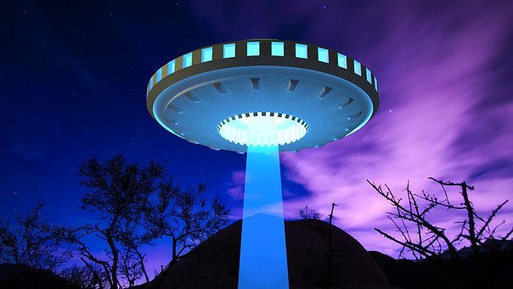
My unusual setting is
---------------------------------
---------------------------------

Alien character words
Super sonic gadgets
Sci-Fi stories are an adventure. They need:
- To take place in space or in the future
- People who go on a journey
- Aliens or species from different planets or worlds
- Unusual fantasy settings
- Super weapons and tekkie gadgets

My setting description

Alien portrait
Sci -fi words to make your story interesting.

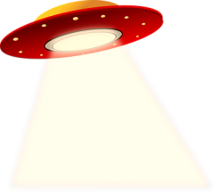
Space problems!

Story structure ideas
Introduction: Introduce the characters and the different world straight away.

What happens in the end?
How do the gadgets help the characters ?
Middle: Where do the characters travel? What happens? What problems do they have?

