Clue 3: Cheeky Chimps
The cheeky chimps are trying to trick you! They have come up with answers to these questions but are they all true? Work out the answers and decide whether the chimps’ answers are true or false.
 | True | False
2 x 6 = 20
The sides of a rectangle are all the same
length.
There are five tens in fifty-six.
These coins total 12p
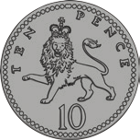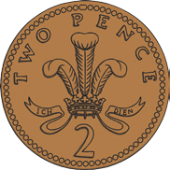
This clock shows half past 10.
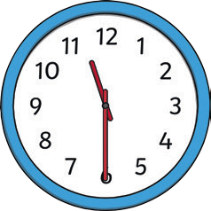
5 x 5 = 25
This line measures 3cm.
1 of the circle is shaded. 2
You would need to add 16 more tigers to make 20 altogether.


Tick one.
If most of the answers are false, the culprit bought birdseed.
If most of the answers are true, the culprit did not buy birdseed.

