Clue 2
Look at the gnome guard’s hats.
Put a tick under the hat patterns that have a line of symmetry.
Put a cross under the hat patterns that do not have a line of symmetry.







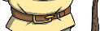
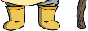
If there are more ticks than crosses, the naughty gnome is less than 30cm tall. If there are more crosses than ticks, the naughty gnome is more than 30cm tall. Clue 2:

