- 1587 + 319 = | - What is 532 X 4?
- What numbers are missing?  8, _____ , 4, 2, _____ ,  -2, _____ , _____ , _____ | 4. Put in the appropriate sign ( < > = ):  5 [ ] one fifth  8925 [ ] 8952  35 X 100 [ ] 350
5. Round to the nearest 10:  19 –  347 – | 6. Circle all of the odd numbers:  8 22 184 3 106  9824 465 77 1571
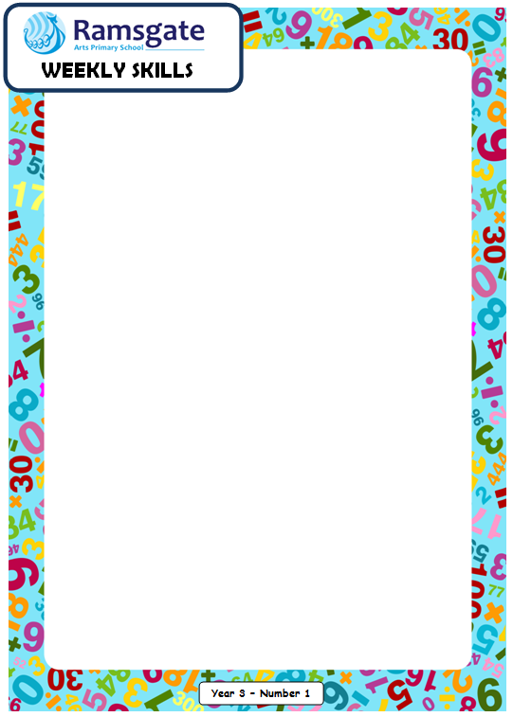
Date: ___________________

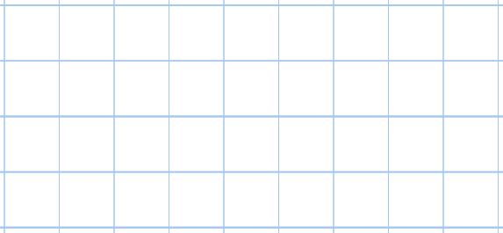  7. Find the difference between 821 and 1584. | 8. What is 726 divided by 3?
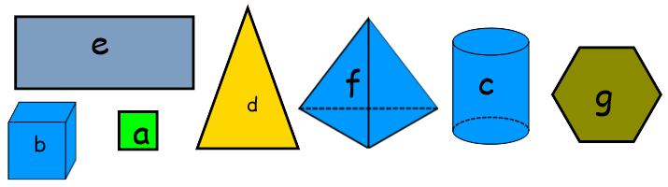
9. Which of these shapes are 3D shapes?
Year 4

Date: ___________________

Year 4
- What is the value of DCXXIV? | 11. Put in the appropriate sign:  8 lots of 7 [ ] 56  3 lots of 4 [ ] 6 lots of 2
12. What is 100 MORE than:  a) 111  b) 3661 | 13. What is 100 LESS than:  a) 2852  b) 9258.4
14. I bought 1086 cupcakes and shared them between Sienna, Megan and Lucy. How many cupcakes did each child get?

15.  a)  b)  c) | FRACTIONS  Give three equivalent fractions to ¾.  What is 2 eighths subtracted from 7 eighths?  Add 5 eighths to one whole and 3 eighths.
Year 4

