RAPS Festival of Neurodiversity and Inclusion

Raps are holding a festival of Neurodiversity and Inclusion from,
Monday March 11th to Friday March 15th.
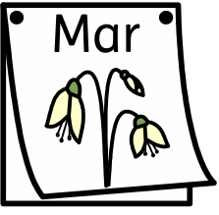

During this week some things will be different, but some things will be the same.

My teacher will have a timetable and they will tell me when things are different, and they will make sure I know what is going to happen.
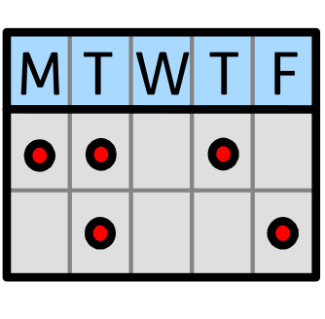

I will have an opportunity to try lots of different activities during the week. Different classes and different year groups will do different activities. Everyone will not do the same thing, but my teacher will make sure I know what I am going to do.

These are some of the things I might be able to try:
Art, Drama, sing and sign, music, inclusive sports, sensory play, a silent disco there will be other activities as well and some visitors may come and talk to my class – my teacher will make sure I know what I am going to do.
RAPS Festival of Neurodiversity and Inclusion is an opportunity for me to learn lots of new things.



