Here are some maths reasoning-style questions. They are all similar to the questions we looked at in class this week!
- Look at the table below then answer the questions underneath.
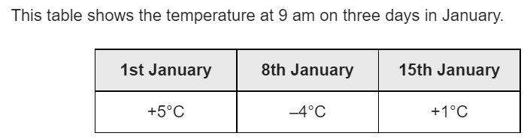

a) What is the difference between the temperature on 1st January and 8th January?

b) On January 22nd, the temperature was 7 degrees lower than on the 15th January. What temperature was it on the 22nd?

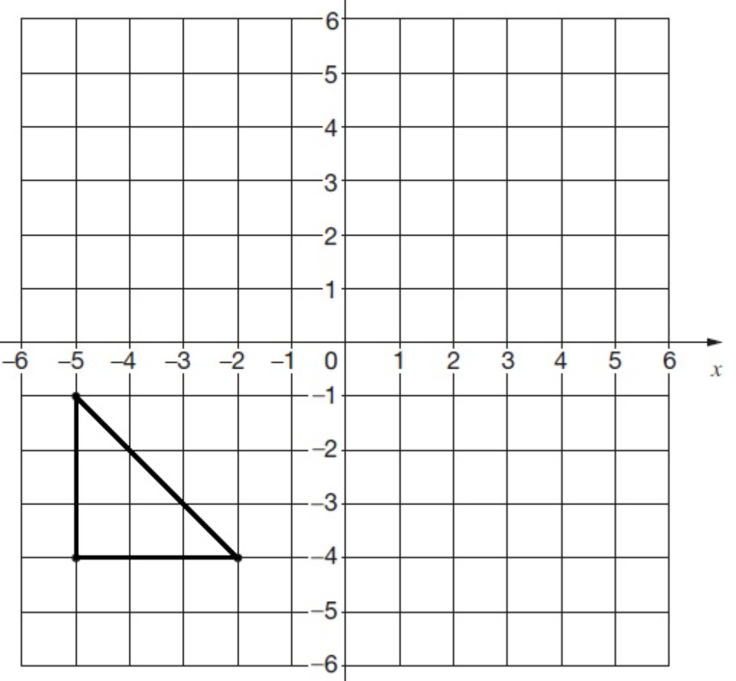
- Here is a triangle on a grid. The triangle is translated 7 right and 5 up. Draw the triangle in its new position.

- Solve the problem:
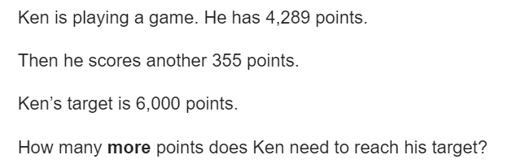

- Solve this problem:
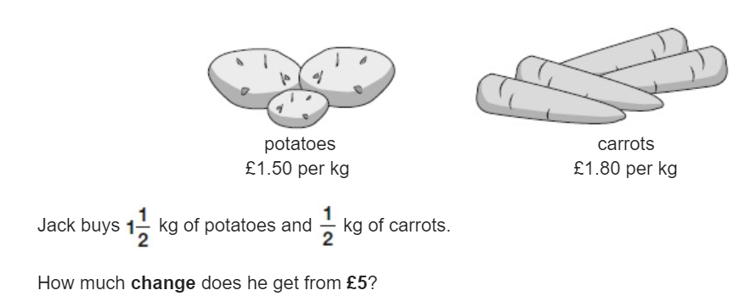

- Solve this problem:
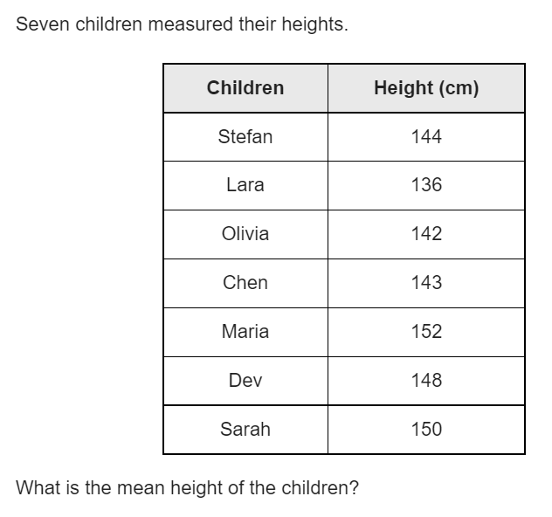

- Solve this problem:


