Love to Learn
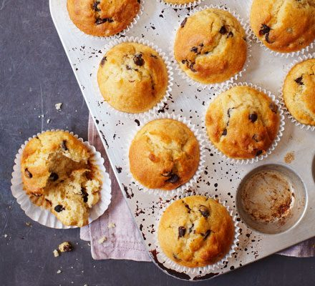
In Year 5, we will be designing, making and selling Fair Trade muffins. The children have been tasked with collecting orders so they know how many to sell. Please note there is a maximum of 3 cakes that can be sold per child. All the profits made from the sale of the muffins will be donated to a Fair Trade charity so please give generously! We will be bringing them home next Thursday so please send children to school with the correct money in a sealed envelope or purse OR bring the money when you collect you child and purchase the cakes after school.

My muffins contain:

Suggested donation:
Please write the names of the people who want to buy a muffin below.

Love to Learn
In Year 5, we will be designing, making and selling Fair Trade muffins. The children have been tasked with collecting orders so they know how many to sell. Please note there is a maximum of 3 cakes that can be sold per child. All the profits made from the sale of the muffins will be donated to a Fair Trade charity so please give generously! We will be bringing them home next Thursday so please send children to school with the correct money in a sealed envelope or purse OR bring the money when you collect you child and purchase the cakes after school.

My muffins contain:

Suggested donation:
Please write the names of the people who want to buy a muffin below.

