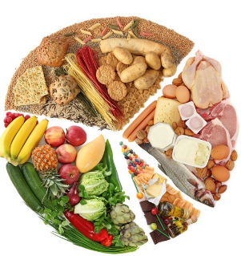
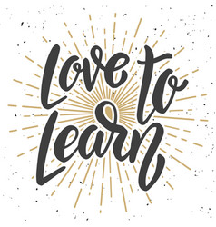
Year 3, you have your
first Love to Learn!
Due: 13.10.2025

Please pick one or challenge yourself to complete more!

1. Can you write a healthy recipe? Using your knowledge of the 5 main food groups, can you plan, write up and make a healthy recipe?

2. Can you keep a food diary for a week? What are the main food groups you regularly use?

3. We know vegetables are good for us, but what vitamins and minerals do they contain? Why not research your favourite fruits and vegetables and write a fact sheet or create a poster or leaflet or powerpoint!

4. Grow your own vegetable or fruit! Can you document your progress from seed to fruit?

5. Can you create a workout video/programme for someone else to follow to stay healthy?

We cannot wait to see what you achieve!

