

TEAM AMIN: LOVE TO LEARN

Due by: Monday 7th October 2019
This term, Team Amin’s RAPS Curriculum topic is called ‘How We Live’, and focuses on healthy bodies and healthy lifestyles. In particular, healthy, balanced diets are an extremely important part of the topic and, of course, important for us too! To encourage the children to think about how balanced their diet is, they are being asked to keep a food diary for a minimum of one week!
Food diary:
- Create your food diary on a page spread, as a booklet or perhaps in a more creative way.
- Log all of the foods and amounts you eat per day.
- Don’t forget to include weekends too!
- Can you identify which food group/s the food items fall under?
- Maybe include a key or a colour code?
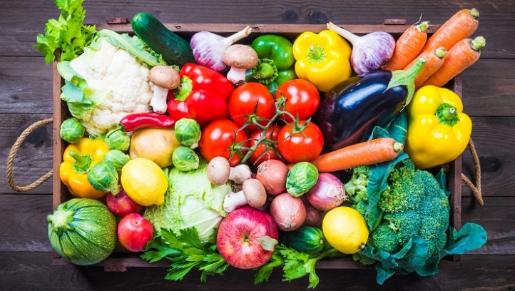
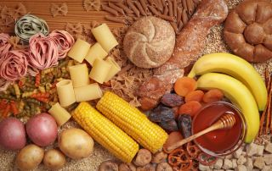
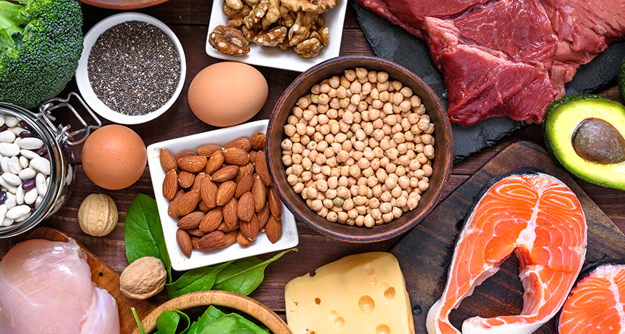
- Illustrate and decorate as you wish!

As a class, we will explore examples of food diaries too to familiarise the children with layout and content! Please do encourage your child to complete their L2L.

