
LOVE TO LEARN
Set: Friday 9th January
Due: By Friday 16th January
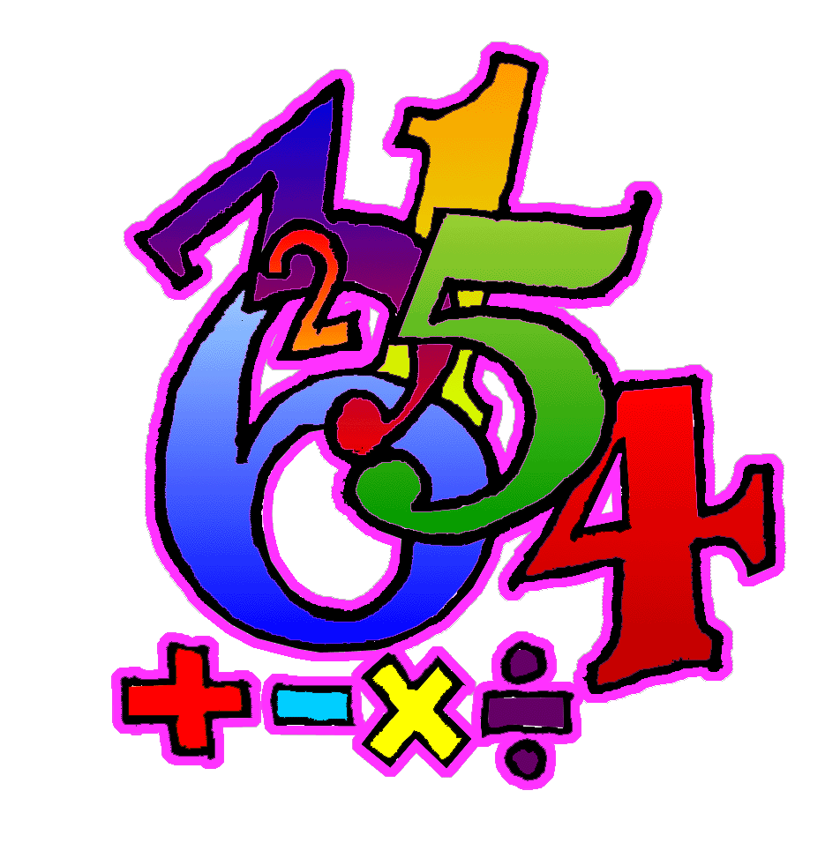
MATHS:
In class, we have been looking at converting fractions to decimals.
- Please change these fractions into decimals (remember, turn them into equivalent fractions with a denominator of 10 or 100 to make it easier):
- $\frac{3}{10}$ b) $\frac{56}{100}$ c) $\frac{2}{5}$ d) $\frac{13}{20}$ e) $\frac{8}{25}$

- Please change these fractions into decimals (use the bus stop method):
- $\frac{7}{8}$ b) $\frac{7}{9}$ (you may need the ‘recurring’ symbol)

LOVE TO LEARN
Set: Friday 9th January
Due: By Friday 16th January
MATHS:
In class, we have been looking at converting fractions to decimals.
- Please change these fractions into decimals (remember, turn them into equivalent fractions with a denominator of 10 or 100 to make it easier):
- $\frac{3}{10}$ b) $\frac{56}{100}$ c) $\frac{2}{5}$ d) $\frac{13}{20}$ e) $\frac{8}{25}$

- Please change these fractions into decimals (use the bus stop method):
- $\frac{7}{8}$ b) $\frac{7}{9}$ (you may need the ‘recurring’ symbol)

