
LOVE TO LEARN
Set: Friday 23rd January
Due: By Friday 30th January
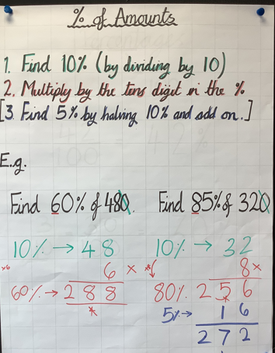

MATHS:
In class, we have been looking at finding percentage of amounts…
- Find…
- 10% of 690
- 30% of 520
- 80% of 9100
- 45% of 680
- 35% of 8600

- OPTIONAL (for HP) Find… 65% of 682

LOVE TO LEARN
Set: Friday 23rd January
Due: By Friday 30th January
MATHS:
In class, we have been looking at finding percentage of amounts…
- Find…
- 10% of 690
- 30% of 520
- 80% of 9100
- 45% of 680
- 35% of 8600

- OPTIONAL (for HP) Find… 65% of 682

