
LOVE TO LEARN
Set: Friday 20th March
Due: By Friday 27th March
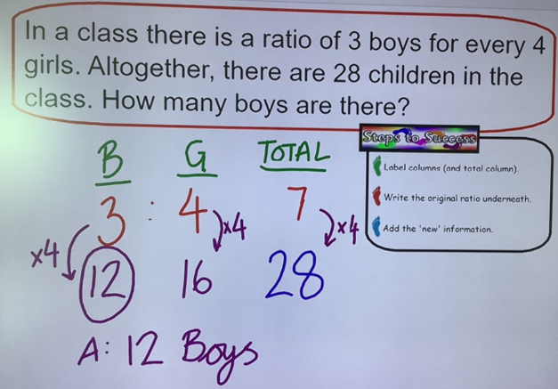

MATHS:
In class, we have been looking at ratio.

- In a class, there are 5 boys for every 4 girls. If there are 15 boys, how many girls would there be?

- A gardener plants three violet flowers for every two yellow ones. How many violet flowers would there be if 30 yellow flowers were planted?

- There are 42 animals in an animal shelter. If there are 6 dogs for every cat, how many dogs are there?

LOVE TO LEARN
Set: Friday 20th March
Due: By Friday 27th March
MATHS:
In class, we have been looking at ratio.

- In a class, there are 5 boys for every 4 girls. If there are 15 boys, how many girls would there be?

- A gardener plants three violet flowers for every two yellow ones. How many violet flowers would there be if 30 yellow flowers were planted?

- There are 42 animals in an animal shelter. If there are 6 dogs for every cat, how many dogs are there?

