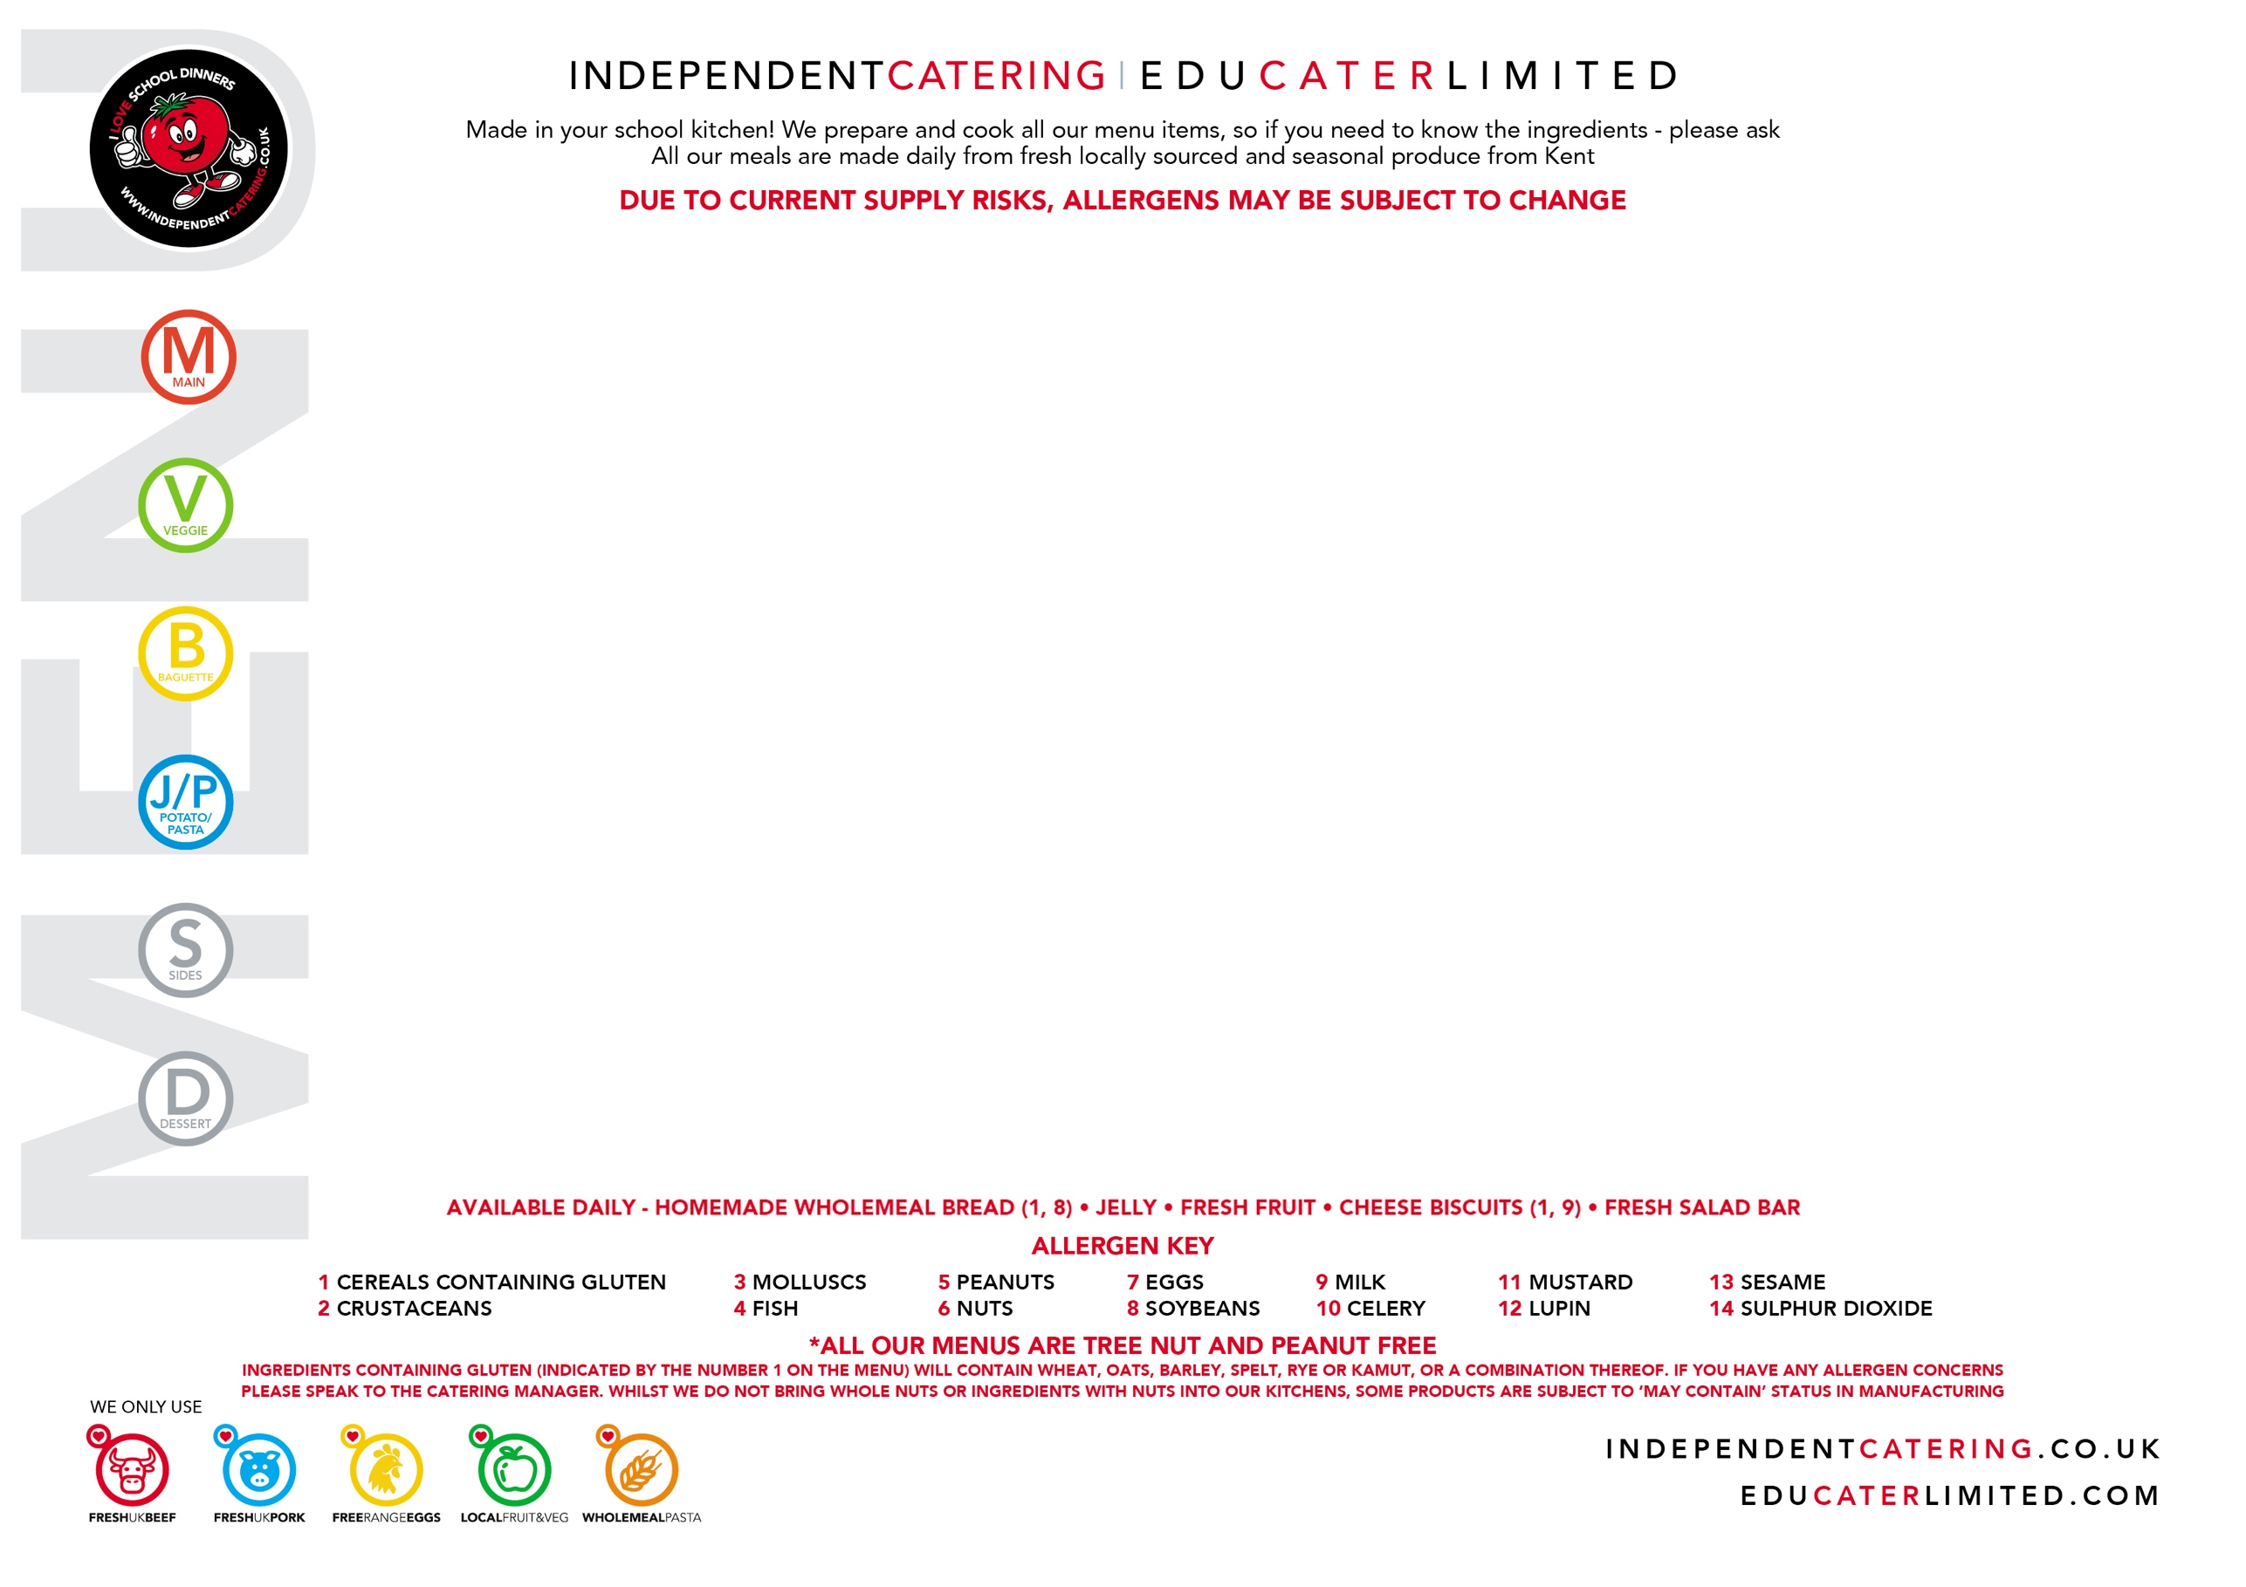

MONDAY 1 JUNE | TUESDAY 2 JUNE | WEDNESDAY 3 JUNE | THURSDAY 4 JUNE | FRIDAY 5 JUNE
Mac n’ Cheese & Garlic Bread  (1,9,11)  (May Contain 8) | Chicken Meatballs served in a Tomato Sauce  (1)  (May Contain 10) | Roast Turkey  with Stuffing and Gravy  (1) | Beef chilli & Nachos  (May Contain 1,11) | Breaded Fish  (1, 4)
Chickpea Korma  with Rice and Naan Bread  (1)  (May Contain 11)  VEGAN | Lentil Meatball in a Tomato Sauce  (1,7) | Butternut Squash & Mixed Bean Turnover  (1)  VEGAN | Quorn Chilli & Nachos  (8)  (May Contain 1,11)  VEGAN | Courgette & Sweetcorn Fritters, with a poached Egg  (1, 7)  Try our Ingredient of the month
Cheese Sandwich (1,8, 9)  Tuna Sandwich (1,4,8)  Ham Sandwich (1,4,8) | Cheese Wrap (1, 9)  Tuna Wrap (1, 4)  Ham Wrap (1,4) | Cheese Sandwich (1,8, 9)  Tuna Sandwich (1,4,8)  Ham Sandwich (1,4,8) | Cheese Wrap (1, 9)  Tuna Wrap (1, 4)  Ham Wrap (1,4) | Cheese Sandwich (1,8, 9)  Tuna Sandwich (1,4,8)  Ham Sandwich (1,4,8)
Fresh Basil Pasta  (1) | Jacket Potato with  Topping of the Day | Mixed Pepper Pasta  (1) | Jacket Potato with  Topping of the Day | Arrabiata Pasta Twirls  (1)
Green Beans  Fresh Salad Bar | Jacket wedges  Garden Peas  and Salad Bar | Roast Potatoes, Fresh Carrots  and Cabbage | Savoury Rice  Broccoli & Salad Bar | Chips, Garden Peas  and Salad Bar
Oaty Apple & berry Crumble  with Custard  (1, 9)  (May Contain 7, 8) | Fresh Strawberry Jelly | Pineapple upside down Sponge  and Custard  (1, 7, 9)  (May Contain 8) | Tutti Frutti Thursday | Cherry Oaty cookie  (1,14)  (May contain 8)
RAMSGATE ARTS PRIMARY
WEEK
1

MONDAY 8 JUNE | TUESDAY 9 JUNE | WEDNESDAY 10 JUNE | THURSDAY 11 JUNE | FRIDAY 12 JUNE
Mild Chicken Korma Curry  with Rice and Naan Bread  (1)  (May Contain 11) | Cheese and  Tomato Pizza  (1, 8, 9)  (May Contain 7) | Roast Beef with a  Yorkshire Pudding and Gravy  (1, 7, 9) | BBQ Chicken Wrap  (1,14) | Fishfingers  (1, 4)  or Salmon Fishcake  (1, 4)
Halloumi, Sweet potato & pepper Quesadilla  (1,9) | Quorn & Vegetable Noodles  (1, 7, 8) | Roast Vegetable Quiche  (1, 7, 9)  (May Contain 8,10)  Try our Ingredient of the month | Roast Vegetable & Bean Wrap  (1)  (May contain 10)  VEGAN | Falafel Burger in a Bun  (1)  (May contain 13)  VEGAN
Cheese Wrap (1, 9)  Tuna Wrap (1, 4)  Ham Wrap (1,4) | Cheese Sandwich (1,8, 9)  Tuna Sandwich (1,4,8)  Ham Sandwich (1,4,8) | Cheese Wrap (1, 9)  Tuna Wrap (1, 4)  Ham Wrap (1,4) | Cheese Sandwich (1,8, 9)  Tuna Sandwich (1,4,8)  Ham Sandwich (1,4,8) | Cheese Sandwich (1,8, 9)  Tuna Sandwich (1,4,8)  Ham Sandwich (1,4,8)
Mac n’ Cheese  (1, 9, 11)  (May Contain 8) | Jacket Potato with  Topping of the Day | Tomato and Basil Pasta  (1) | Jacket Potato with  Topping of the Day | Mixed Vegetable  Ragu Twirls  (1)
Fresh Broccoli  and Salad Bar | Fresh Carrots  and Salad Bar | Roast Potatoes, Cabbage and Peas | Broccoli, Herby New Potatoes  and Salad Bar | Chips, Peas, Baked Beans  and Salad Bar
Iced Carrot Cake  (1, 7, 9)  (May Contain 8) | Shortbread served with Watermelon  (1)  (May Contain 8) | Chocolate Sponge and Chocolate Sauce  (1, 7, 9)  (May Contain 8) | Tutti Frutti Thursday | Strawberry Cup Cake  (1, 7)  (May Contain 8)
RAMSGATE ARTS PRIMARY

WEEK
2
MONDAY 15 JUNE | TUESDAY 16 JUNE | WEDNESDAY 17 JUNE | THURSDAY 18 JUNE | FRIDAY 19 JUNE
Open Beef Burrito  (1,9)  (May Contain 10,11) | Homemade Sausage Roll  (1,14) | Roast Gammon  and Pineapple  with Gravy | 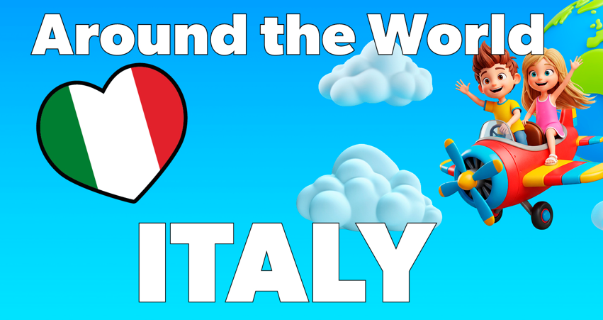  Italian Meatballs with Spaghetti served with Focaccia  (1, 8)  Pasta Arrabbiata  (1)  Cheese Wrap (1, 9)  Tuna Wrap (1, 4)  Ham Wrap (1,4)  Jacket Potato with  Topping of the Day  Italian Oven Roasted Vegetables  Try our Ingredient of the month  Chocolate Torta Della Nonna  (1, 7, 9)  Chocolate Tart  (May Contain 8) | Breaded Fish  (1, 4)
Mixed Bean Chilli Burrito  (May Contain 1,10, 11)  VEGAN | Vegetarian Sausage Roll  (1)  VEGAN | Cauliflower & Broccoli Cheese Yorkshire pudding  (1,7,9,11)  (May Contain 8) |  | Quorn Dippers  (1,8)  VEGAN
Cheese Sandwich (1,8, 9)  Tuna Sandwich (1,4,8)  Ham Sandwich (1,4,8) | Cheese Wrap (1, 9)  Tuna Wrap (1, 4)  Ham Wrap (1,4) | Cheese Sandwich (1,8, 9)  Tuna Sandwich (1,4,8)  Ham Sandwich (1,4,8) |  | Cheese Sandwich (1,8, 9)  Tuna Sandwich (1,4,8)  Ham Sandwich (1,4,8)
Jacket Potato with  Topping of the Day | Roasted Vegetable  Pasta Bows  (1)  Try our Ingredient of the month | Jacket Potato with  Topping of the Day |  | Jacket Potato with  Topping of the Day
Grated Carrots  and Salad Bar | Herby New Potatoes,  Baked Beans  and Salad Bar | Roast Potatoes, Fresh Carrots  and Broccoli |  | Chips, Garden Peas  and Salad Bar
Lemon Drizzle cake  (1,7)  (May Contain 8) | Peach Sponge & Custard  (1,7,9)  (May Contain 8) | Homemade Scone Fresh Cream & Strawberries  (1,9)  (May Contain 8) |  | Rice Krispie cake  (1,9)
WEEK
3
RAMSGATE ARTS PRIMARY

MONDAY 22 JUNE | TUESDAY 23 JUNE | WEDNESDAY 24 JUNE | THURSDAY 25 JUNE | FRIDAY 26 JUNE
Mac n’ Cheese & Garlic Bread  (1,9,11)  (May Contain 8) | Chicken Meatballs served in a Tomato Sauce  (1)  (May Contain 10) | Roast Turkey  with Stuffing and Gravy  (1) | Beef chilli & Nachos  (May Contain 1,11) | Breaded Fish  (1, 4)
Chickpea Korma  with Rice and Naan Bread  (1)  (May Contain 11)  VEGAN | Lentil Meatball in a Tomato Sauce  (1,7) | Butternut Squash & Mixed Bean Turnover  (1)  VEGAN | Quorn Chilli & Nachos  (8)  (May Contain 1,11)  VEGAN | Courgette & Sweetcorn Fritters, with a poached Egg  (1, 7)  Try our Ingredient of the month
Cheese Sandwich (1,8, 9)  Tuna Sandwich (1,4,8)  Ham Sandwich (1,4,8) | Cheese Wrap (1, 9)  Tuna Wrap (1, 4)  Ham Wrap (1,4) | Cheese Sandwich (1,8, 9)  Tuna Sandwich (1,4,8)  Ham Sandwich (1,4,8) | Cheese Wrap (1, 9)  Tuna Wrap (1, 4)  Ham Wrap (1,4) | Cheese Sandwich (1,8, 9)  Tuna Sandwich (1,4,8)  Ham Sandwich (1,4,8)
Jacket Potato with  Topping of the Day | Vegetable Ragu Twirls  (1) | Jacket Potato with  Topping of the Day | Creamy Tomato Pasta  (1,9) | Jacket Potato with  Topping of the Day
Green Beans  Fresh Salad Bar | Jacket wedges  Garden Peas  and Salad Bar | Roast Potatoes, Fresh Carrots  and Cabbage | Savoury Rice  Broccoli & Salad Bar | Chips, Garden Peas  and Salad Bar
Oaty Apple & berry Crumble  with Custard  (1, 9)  (May Contain 7, 8) | Fresh Strawberry Jelly | Pineapple upside down Sponge  and Custard  (1, 7, 9)  (May Contain 8) | Tutti Frutti Thursday | Cherry Oaty cookie  (1,14)  (May contain 8)
WEEK
4
RAMSGATE ARTS PRIMARY

MONDAY 29 JUNE | TUESDAY 30 JUNE | WEDNESDAY 1 JULY | THURSDAY 2 JULY | FRIDAY 3 JULY
Mild Chicken Korma Curry  with Rice and Naan Bread  (1)  (May Contain 11) | Cheese and  Tomato Pizza  (1, 8, 9)  (May Contain 7) | Roast Beef with a  Yorkshire Pudding and Gravy  (1, 7, 9) | BBQ Chicken Wrap  (1,14) | Fishfingers  (1, 4)  or Salmon Fishcake  (1, 4)
Halloumi, Sweet potato & pepper Quesadilla  (1,9) | Quorn & Vegetable Noodles  (1, 7, 8) | Roast Vegetable Quiche  (1, 7, 9)  (May Contain 8,10) | Roast Vegetable & Bean Wrap  (1)  (May contain 10)  VEGAN | Falafel Burger in a Bun  (1)  (May contain 13)  VEGAN
Cheese Wrap (1, 9)  Tuna Wrap (1, 4)  Ham Wrap (1,4) | Cheese Sandwich (1,8, 9)  Tuna Sandwich (1,4,8)  Ham Sandwich (1,4,8) | Cheese Wrap (1, 9)  Tuna Wrap (1, 4)  Ham Wrap (1,4) | Cheese Sandwich (1,8, 9)  Tuna Sandwich (1,4,8)  Ham Sandwich (1,4,8) | Cheese Sandwich (1,8, 9)  Tuna Sandwich (1,4,8)  Ham Sandwich (1,4,8)
Chunky Tomato Twirls  (1) | Jacket Potato with  Topping of the Day | Tomato and Basil Pasta  (1) | Jacket Potato with  Topping of the Day | Mixed Vegetable  Ragu Twirls  (1)
Fresh Broccoli  and Salad Bar | Fresh Carrots  and Salad Bar | Roast Potatoes, Cabbage and Peas | Broccoli, Herby New Potatoes  and Salad Bar | Chips, Peas, Baked Beans  and Salad Bar
Iced Carrot Cake  (1, 7, 9)  (May Contain 8) | Shortbread served with Watermelon  (1)  (May Contain 8) | Chocolate Sponge and Chocolate Sauce  (1, 7, 9)  (May Contain 8) | Tutti Frutti Thursday  Try our Ingredient of the month | Strawberry Cup Cake  (1, 7)  (May Contain 8)
WEEK
5

RAMSGATE ARTS PRIMARY

MONDAY 6 JULY | TUESDAY 7 JULY | WEDNESDAY 8 JULY | THURSDAY 9 JULY | FRIDAY 10 JULY
Open Beef Burrito  (1,9)  (May Contain 10,11) | Homemade Sausage Roll  (1,14) | Roast Gammon  and Pineapple  with Gravy | Beef Spaghetti Bolognaise  and Garlic Bread  (1, 8)  (May Contain 10) | Breaded Fish  (1, 4)
Mixed Bean Chilli Burrito  (May Contain 1,10, 11)  VEGAN | Vegetarian Sausage Roll  (1)  VEGAN | Cauliflower & Broccoli Cheese Yorkshire pudding  (1,7,9,11)  (May Contain 8) | Lentil and Bean Spaghetti Bolognaise and Garlic Bread  (1)  (May Contain 8)  VEGAN | Quorn Dippers  (1,8)  VEGAN
Cheese Sandwich (1,8, 9)  Tuna Sandwich (1,4,8)  Ham Sandwich (1,4,8) | Cheese Wrap (1, 9)  Tuna Wrap (1, 4)  Ham Wrap (1,4) | Cheese Sandwich (1,8, 9)  Tuna Sandwich (1,4,8)  Ham Sandwich (1,4,8) | Cheese Wrap (1, 9)  Tuna Wrap (1, 4)  Ham Wrap (1,4) | Cheese Sandwich (1,8, 9)  Tuna Sandwich (1,4,8)  Ham Sandwich (1,4,8)
Jacket Potato with  Topping of the Day | Roasted Courgette  Ragu Twirls  (1)  Try our Ingredient of the month | Jacket Potato with  Topping of the Day | Fresh Pesto Pasta  (1) | Jacket Potato with  Topping of the Day
Grated Carrots  and Salad Bar | Herby New Potatoes,  Baked Beans  and Salad Bar | Roast Potatoes, Fresh Carrots  and Broccoli | Broccoli, Herby New Potatoes  and Salad Bar | Chips, Garden Peas  and Salad Bar
Lemon Drizzle cake  (1,7)  (May Contain 8) | Peach Sponge & Custard  (1,7,9)  (May Contain 8) | Homemade Scone Fresh Cream & Strawberries  (1,9)  (May Contain 8) | Tutti Frutti Thursday  Try our Ingredient of the month | Rice Krispie cake  (1,9)
WEEK
6

RAMSGATE ARTS PRIMARY

WEEK
7

MONDAY 13 JULY | TUESDAY 14 JULY | WEDNESDAY 15 JULY | THURSDAY 16 JULY | FRIDAY 17 JULY
BBQ Chicken Wrap  (1,14) | 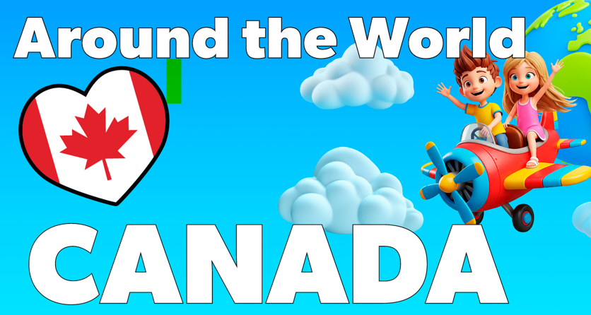  Bacon Mac n’ Cheese  (1, 9, 11)  (May Contain 8)  Roasted Red Peppers,  stuffed with Broccoli and Maple Tabbouleh  (1)  Cheese Wrap (1, 9)  Tuna Wrap (1, 4)  Ham Wrap (1,4)  Jacket Potato with Choice of Toppings  Peas , Sweetcorn and Salad Bar  Mixed Canadian Salad  Canadian Blueberry Muffins  (1, 7, 9)  (May Contain 8)  Try our Ingredient of the month | Roast Turkey  with Stuffing and Gravy  (1) | Beef chilli & Nachos  (May Contain 1,11) | Breaded Fish  (1, 4)
Roast Vegetable & Bean Wrap  (1)  (May contain 10)  VEGAN |  | Butternut Squash & Mixed Bean Turnover  (1)  VEGAN | Quorn Chilli & Nachos  (8)  (May Contain 1,11)  VEGAN | Courgette & Sweetcorn Fritters, with a poached Egg  (1, 7)
Cheese Sandwich (1,8, 9)  Tuna Sandwich (1,4,8)  Ham Sandwich (1,4,8) |  | Cheese Sandwich (1,8, 9)  Tuna Sandwich (1,4,8)  Ham Sandwich (1,4,8) | Cheese Wrap (1, 9)  Tuna Wrap (1, 4)  Ham Wrap (1,4) | Cheese Sandwich (1,8, 9)  Tuna Sandwich (1,4,8)  Ham Sandwich (1,4,8)
Fresh Basil Pasta  (1) |  | Mixed Pepper Pasta  (1) | Jacket Potato with  Topping of the Day | Arrabiata Pasta Twirls  (1)
Broccoli, Herby New Potatoes  and Salad Bar |  | Roast Potatoes, Fresh Carrots  and Cabbage | Savoury Rice  Broccoli & Salad Bar | Chips, Garden Peas  and Salad Bar
Oaty Apple & Berry Crumble  with Custard  (1, 9)  (May Contain 7, 8) |  | Pineapple upside down Sponge  and Custard  (1, 7, 9)  (May Contain 8) | Tutti Frutti Thursday  Try our Ingredient of the month | Cherry Oaty cookie  (1,14)  (May contain 8)

RAMSGATE ARTS PRIMARY

