
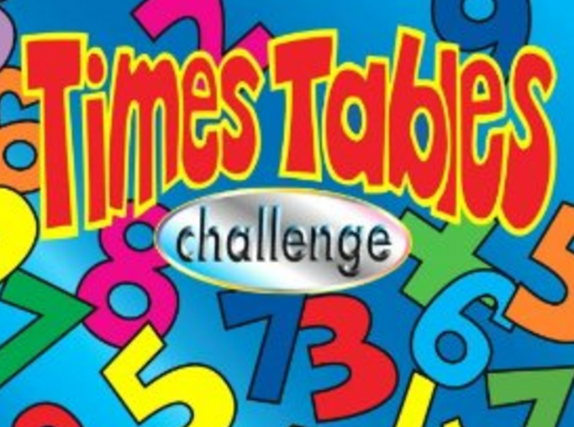
SCORE:
100 Club

NAME: _______________________________________

10x6= | 4x2= | 1x7= | 11x5= | 8x3= | 9x7= | 2x4= | 0x6= | 8x2= | 1x4=
7x4= | 0x5= | 3x2= | 6x4= | 2x5= | 1x2= | 5x7= | 12x2= | 11x9= | 10x2=
10x10= | 8x6= | 4x3= | 8x7= | 11x3= | 10x9= | 7x6= | 5x4= | 12x8= | 5x9=
3x9= | 9x5= | 11x7= | 0x10= | 6x3= | 2x7= | 4x9= | 3x3= | 6x5= | 4x8=
5x2= | 5x5= | 12x3= | 8x4= | 10x8= | 4x4= | 5x8= | 7x7= | 9x8= | 2x2=
1x10= | 11x4= | 4x6= | 4x4= | 7x5= | 8x9= | 6x2= | 12x5= | 7x3= | 4x7=
4x5= | 12x7= | 2x8= | 3x2= | 1x5= | 10x3= | 11x8= | 10x4= | 1x8= | 11x2=
6x8= | 2x3= | 8x0= | 7x8= | 9x6= | 6x7= | 5x6= | 8x8= | 5x3= | 12x6=
7x9= | 3x6= | 7x2= | 2x9= | 10x7= | 1x3= | 6x9= | 5x5= | 4x0= | 3x4=
9x3= | 10x5= | 3x7= | 8x5= | 9x4= | 12x4= | 11x6= | 9x2= | 3x6= | 12x9=

