
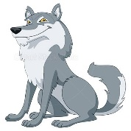
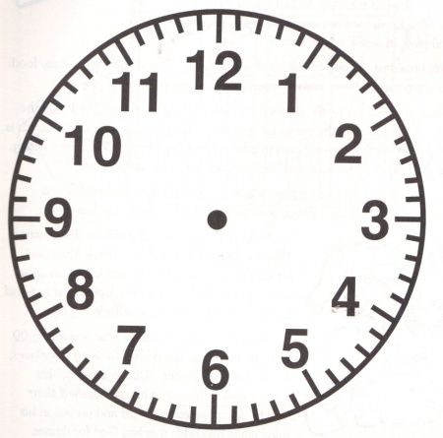
What’s the time Mr. Wolf?

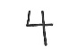

Draw in the time for different activities dusing the day

