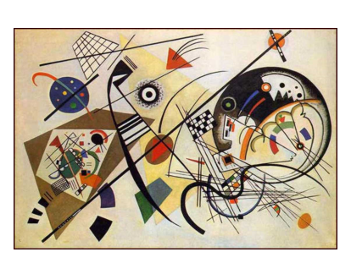
Art & Maths - Kandinsky

I have included at least:
Horizontal lines (5cm and 9cm)
Vertical lines (6cm and 10.5 cm)
2 pairs of diagonal parallel lines
2 pairs of perpendicular lines
2 Acute, obtuse and right angles
2 regular quadrilaterals
A pentagon and a hexagon
3 other quadrilaterals

