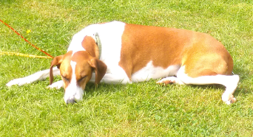

My dog is called Hetty and she is a sleek tan and white cross-breed from Spain!
She is medium sized with long athletic legs and a slim neck. She also has a long pointy nose that is always black and wet! Her ears are floppy and a little bit wonky. Her fur is short and silky and she has beautiful tan and white markings. She has a long slim tail which is all brown with a white tip on the end and it is always wagging!

