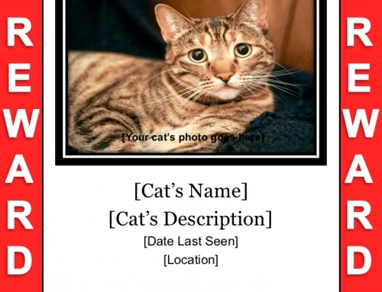
Jimmy
Beautiful brown male tabby cat.
He has striking yellow eyes. Jimmy is timid
but he answers to his name. Very missed!
He was last seen on 7th April 2020 on Chestnut Road, Ramsgate.
Please call 07473 556 789
LOST!

