
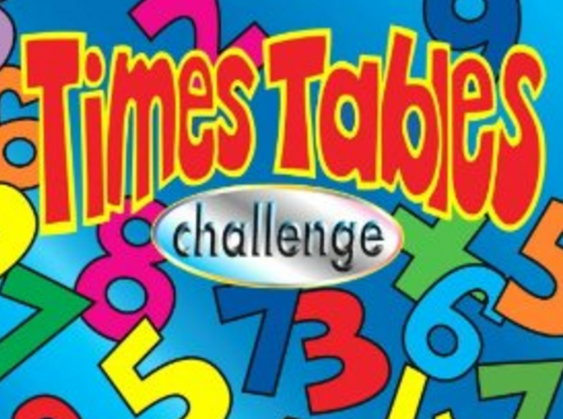
SCORE:
x 6 x 7 x 8

NAME: _______________________________________

1 x 8 = | 6 x 6 = | 8 x 8 = | 0 x 8 = | 1 x 6 =
6 x 3 = | 7 x 0 = | 6 x 4 = | 7 x 6 = | 7 x 3 =
5 x 7 = | 8 x 10 = | 7 x 11 = | 6 x 5 = | 8 x 7 =
7 x 8 = | 8 x 3 = | 9 x 8 = | 7 x 7 = | 12 x 8 =
6 x 7 = | 2 x 7 = | 6 x 12 = | 3 x 6 = | 6 x 12 =
9 x 8 = | 10 x 7 = | 2 x 8 = | 7 x 1 = | 4 x 8 =
10 x 6 = | 6 x 8 = | 7 x 4 = | 6 x 3 = | 11 x 6 =
5 x 8 = | 0 x 6 = | 12 x 7 = | 7 x 8 = | 10 x 8 =
9 x 7 = | 4 x 7 = | 9 x 6 = | 6 x 12 = | 4 x 6 =
2 x 6 = | 8 x 4 = | 3 x 8 = | 11 x 8 = | 7 x 3 =

