
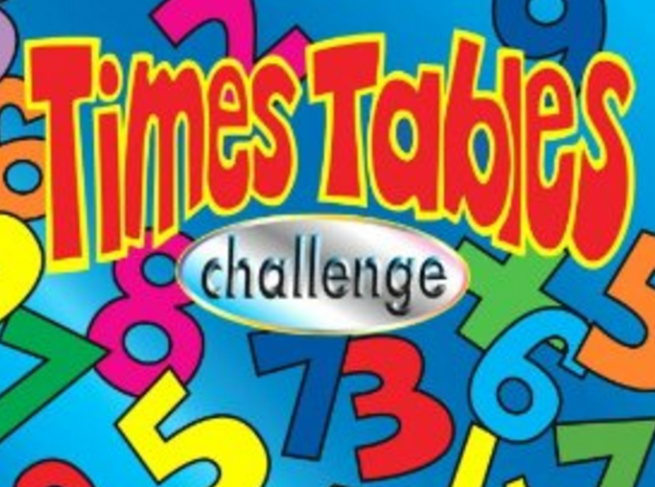
SCORE:
x 2 x5 x 10

NAME: _______________________________________

5 x 2 = | 0 x 5 = | 1 x 5 = | 2 x 4 = | 1 x 2 =
2 x 8 = | 10 x 2 = | 8 x 5 = | 5 x 10 = | 5 x 0 =
8 x 10 = | 10 x 9 = | 3 x 5 = | 0 x 2 = | 7 x 2 =
10 x 5 = | 3 x 2 = | 6 x 5 = | 8 x 5 = | 10 x 6 =
2 x 0 = | 3 x 10 = | 2 x 10 = | 3 x 2 = | 4 x 5 =
2 x 5 = | 7 x 5 = | 5 x 9 = | 4 x 2 = | 6 x 10 =
10 x 10 = | 0 x 10 = | 7 x 10 = | 2 x 3 = | 9 x 2 =
2 x 2 = | 2 x 7 = | 5 x 5 = | 9 x 10 = | 5 x 8 =
2 x 9 = | 4 x 10 = | 6 x 2 = | 7 x 5 = | 1 x 10 =
9 x 5 = | 6 x 5 = | 5 x 7 = | 8 x 2 = | 2 x 6 =

