
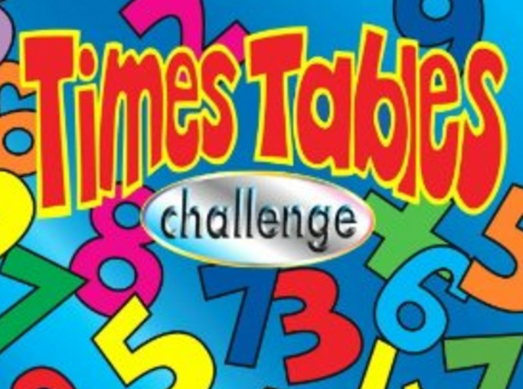
SCORE:
x 3 x4 x 8

NAME: _______________________________________

1 x 8 = | 12 x 3 = | 8 x 8 = | 0 x 3 = | 4 x 4 =
6 x 3 = | 3 x 9 = | 6 x 4 = | 3 x 12 = | 7 x 3 =
0 x 8 = | 8 x 10 = | 1 x 3 = | 11 x 4 = | 0 x 4 =
7 x 8 = | 8 x 3 = | 9 x 8 = | 5 x 4 = | 12 x 8 =
4 x 2 = | 3 x 4 = | 12 x 4 = | 3 x 6 = | 2 x 3 =
10 x 3 = | 4 x 5 = | 2 x 8 = | 11 x 3 = | 4 x 8 =
3 x 5 = | 6 x 8 = | 7 x 4 = | 6 x 3 = | 9 x 4 =
5 x 8 = | 3 x 3 = | 4 x 10 = | 1 x 4 = | 10 x 8 =
2 x 4 = | 4 x 7 = | 10 x 4 = | 5 x 3 = | 4 x 6 =
4 x 3 = | 8 x 4 = | 3 x 8 = | 11 x 8 = | 9 x 3 =

