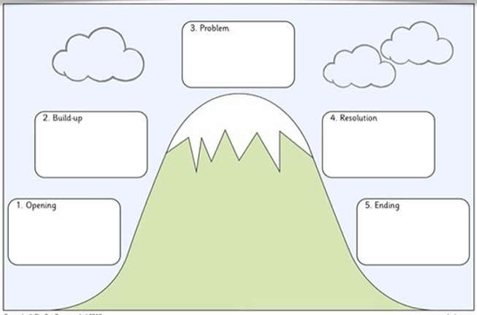
The Story of the Ugly Duckling
He looked at his reflection and he
saw that was a handsome swan!
Just like the other swans!
He has found where he belonged
and lived happily ever after!
One day some swans discovered him and asked why he was all alone. They invited him to come with them and told him he was not ugly at all – he was a swan!
He became very lonely for no one would play with him. They said he looked strange. He didn’t feel like he belonged anywhere and he became very sad.
Finally it began to hatch. When the
chick popped out it didn’t look like the others! All the other chicks said he was ugly. So he went off to look for some other friends.
Once upon a time there was a mother duck and she laid 6 eggs.
All the eggs looked the same except for the last one. It was much bigger and it took the longest to hatch.

