1.5.20
IALT test ideas and methods.
IALT work logically and systematically.
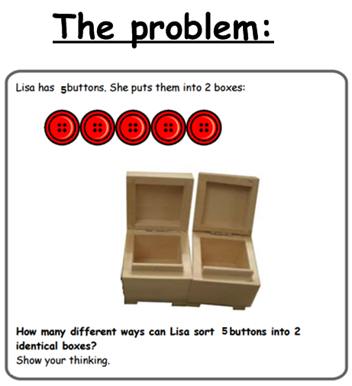

1.5.20
IALT test ideas and methods.
IALT work logically and systematically.
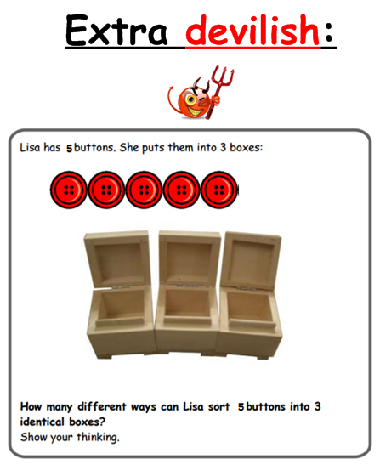
EXTENSION: What about if I had 9 buttons and 3 boxes?



