
Viking Academy Trust

Staff Acceptable
Use Policy

The VIKING ACADEMY TRUST Staff Acceptable Use Policy has been written following advice from SWGFL.
Approved by the Trust: Term 4 2016
Reviewed annually: Term 1
Last review date: Term 1 2019
Signed: 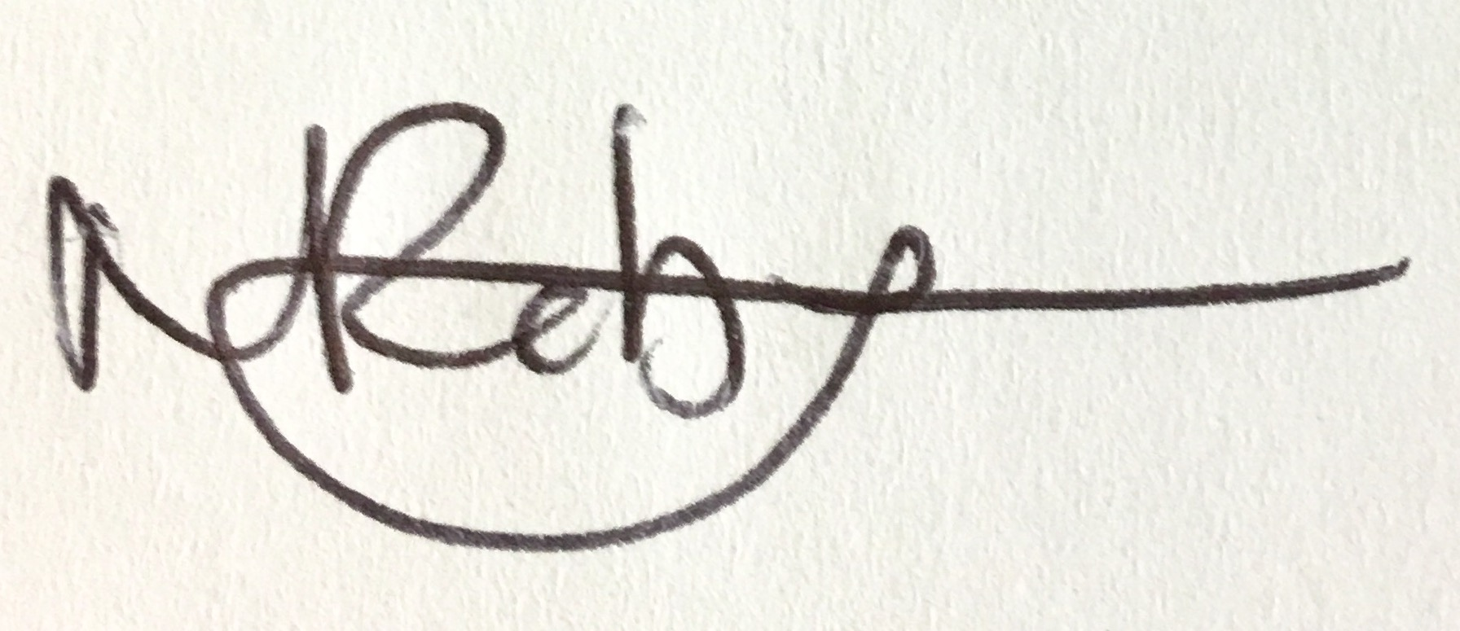 Chair of Trustees

Staff (and Volunteer)
Acceptable Use Policy
The Viking Academy Trust
Schools in the Viking Academy Trust (VAT)

These are:

Ramsgate Arts Primary School
Chilton Primary School
Upton Junior School

This policy is for Ramsgate Arts Primary School
As a professional organisation with responsibility for safeguarding, it is important that staff take all possible and necessary measures to protect data and information systems from infection, unauthorised access, damage, loss, abuse and theft. All members of staff have a responsibility to use the school’s computer system in a professional, lawful, and ethical manner. To ensure that members of staff are fully aware of their professional responsibilities when using technology, they are asked to read and sign this Acceptable Use Policy.
This is not an exhaustive list; all members of staff are reminded that IT use should be consistent with the school ethos, school policies, national/local guidance and expectations, and the law.
- I understand that Information Systems and IT include networks, data and data storage, online and offline communication technologies and access devices. Examples include laptops, mobile phones, tablets, digital cameras, email and social media sites.
- School owned information systems must be used appropriately. I understand that the Computer Misuse Act 1990 makes the following criminal offences: to gain unauthorised access to computer material; to gain unauthorised access to computer material with intent to commit or facilitate commission of further offences or to modify computer material without authorisation.
- I understand that any hardware and software provided by my workplace for staff use can only be used by members of staff and only for educational use. To prevent unauthorised access to systems or personal data, I will not leave any information system unattended without first logging out or locking my login as appropriate. I will protect the devices in my care from unapproved access or theft.
- I will respect system security and will not disclose any password or security information. I will use a ‘strong’ password to access school systems. A strong password has numbers, letters and symbols, with 8 or more characters, does not contain a dictionary word and is only used on one system. (Please do not use the same password to log in to Office 365, your laptop or Bromcom)
- I will not attempt to install any purchased or downloaded software, including browser toolbars, or hardware without permission from the system manager.
- I will ensure that any personal data of pupils, staff or parents/carers is kept in accordance with the Data Protection legislation (including GDPR).
  - This means that all personal data will be obtained and processed fairly and lawfully, only kept for specific purposes, held no longer than necessary and will be kept private and secure with appropriate security measures in place, whether used in the workplace, hosted online or accessed remotely.
  - Any data being removed from the school site (such as via email) will be suitably protected. Encryption methods have been advised by the school. Memory sticks / CDs etc. are not permitted to store school data.
  - Any images or videos of pupils will only be used as stated in the school image use policy and will always reflect parental consent.

- I will not keep documents which contain school-related sensitive or personal information, including images, files, videos and emails, on any personal devices, such as laptops, digital cameras, ipads and mobile phones. I will use the school shared area or Sharepoint to upload any work documents and files in a password protected environment.
- I will not store any personal information on the school computer system including any school laptop or similar device issued to members of staff that is unrelated to school activities, such as personal photographs, files or financial information.
- I will respect copyright and intellectual property rights.
- I have read and understood the school online safety policy which covers the requirements for safe IT use, including using appropriate devices, safe use of social media and the supervision of pupils within the classroom and other working spaces.
- I will immediately report any illegal, inappropriate or harmful material or incidents I become aware of, to the Designated Safeguarding Lead (Nick Budge).
- I will not attempt to bypass any filtering and/or security systems put in place by the school. If I suspect a computer or system has been damaged or affected by a virus or other malware, or if I have lost any school related documents or files, I will report this via the fault reporting system (https://faultlog.net/report.php?school=chilton&id=p7Yt) to the IT support team. Any issues relating to the school filtering system should be reported through the e-safety log
- My electronic communications with current or past pupils, parents/carers and other professionals will take place within clear and explicit professional boundaries and will be transparent and open to scrutiny.
  - All communication will take place via school approved communication channels, such as a school provided email address or telephone number, and not via my personal devices or communication channels, such as personal email, social networking or mobile phones.
  - Any pre-existing relationships or situations that may compromise this will be discussed with the Designated Safeguarding Lead (Nick Budge).

- I will ensure that my online reputation and use of IT and information systems are compatible with my professional role, whether using school or personal systems. This includes the use of email, text, social media, social networking, gaming and any other devices or websites.
  - I will take appropriate steps to protect myself online as outlined in the Online Safety Policy and will ensure that my use of IT and the internet will not undermine my professional role, interfere with my work duties and will be in accordance with the school code of conduct and the law.

- I will not create, transmit, display, publish or forward any material online that is likely to harass, cause offence, inconvenience or needless anxiety to any other person, or anything which could bring my professional role, the school, or the County Council, into disrepute.
- I will promote online safety with the pupils in my care and will help them to develop a responsible attitude to safety online, system use and to the content they access or create.
- If I have any queries or questions regarding safe and professional practice online either in school or off site, I will raise them with the Designated Safeguarding Lead (Nick Budge).
- I understand that my use of the school information systems, including any devices provided by the school, including the school internet and school email, may be monitored and recorded to ensure the safety of children and staff and to ensure policy compliance. This monitoring will be proportionate and will take place in accordance with data protection, privacy and human rights legislation.
- I understand that the school may exercise its right to monitor the use of information systems, including internet access and the interception of emails, to monitor policy compliance. Where it believes unauthorised and/or inappropriate use, or unacceptable or inappropriate behaviour may be taking place, the school may invoke its disciplinary procedures. If the school suspects criminal offences have occurred, the matter will be brought to the attention of the relevant law enforcement organisation.
I have read, understood and agreed to comply with Ramsgate Arts Primary School’s Staff Acceptable Use Policy
Name: ………………………
Signed: ………………………....
Date: ………

VIKING ACADEMY TRUST
Mrs Michaela Lewis ~ Executive Headteacher
‘One Childhood One Chance’

LAPTOP COMPUTERS FOR TEACHERS
LONG TERM LOAN AGREEMENT
TEACHER’S NAME :
I understand that I have been loaned one laptop computer upon the following conditions:
- Ownership of the computer is Viking Academy Trust
- Registration of the computer must be carried out by myself
- Insurance arrangements are my responsibility entirely
- When used off site this equipment is used purely for business use.
- The computer will be returned to school on a half termly basis for maintenance
- The computer will be returned in good condition to school upon termination of my employment with the academy
- I accept the specification of the computer correct as follows:

Laptop Make : Asset Tag #
Serial Number:

SIGNED _______________________ DATE ______________________



Ramsgate Arts Primary School
www.ramsgateartsprimarychool.co.uk
Ramsgate Arts Primary School, Ramsgate Free School and Upton Junior School, are operated by Viking Academy Trust, which is a charitable company limited by guarantee and registered in England and Wales with company number 09449979. The Registered Office is at Ramsgate Arts Primary School, Chilton Lane, Ramsgate, Kent. CT11 0LQ
Upton Junior School
www.uptonjunior.com
Chilton Primary School
www.chiltonprimaryschool.co.uk

