
Viking Academy Trust

Safeguarding Policy
Ramsgate Arts Primary School

The VIKING ACADEMY TRUST ‘Safeguarding Policy’ for Ramsgate Arts Primary School’ has been written after consultation with staff and following DfE guidance.
Approved by the Trust: Term 4 2017
Reviewed annually: Term 1
Last review date: Term 1 2019
Signed: 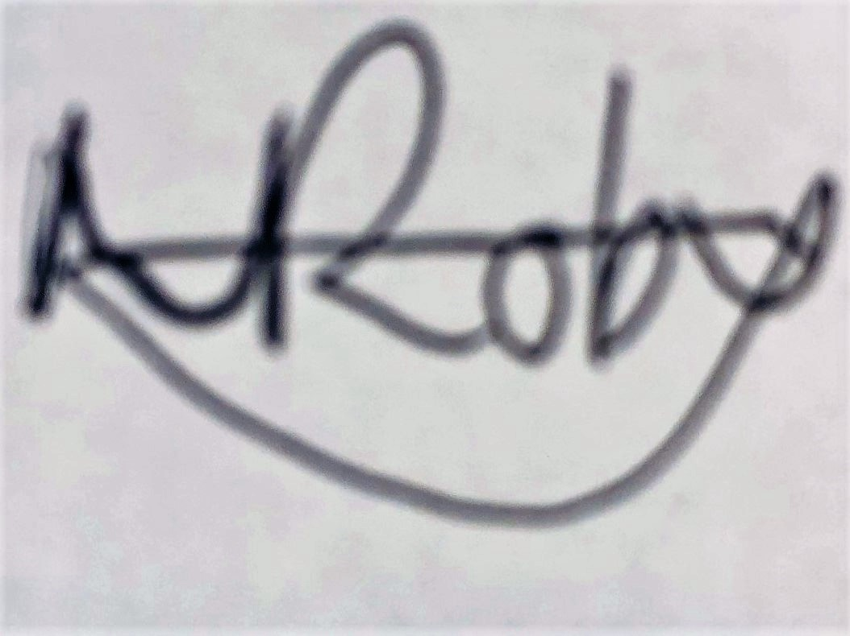 Chair of Trust

Safeguarding Policy
The Viking Academy Trust
Ramsgate Arts Primary School
Schools in the Viking Academy Trust (VAT)

Ramsgate Arts Primary School
Chilton Primary School
Upton Junior School

This Safeguarding Policy is specific to Ramsgate Arts Primary School.

Key Contact Personnel in School
Designated Safeguarding Lead | Mr N Budge (Lead DSL)  headofschool@ramsgateartsprimaryschool.co.uk  07813 797751
Deputy Safeguarding Leads | Mrs Hanna Beech  hanna.beech@ramsgateartsprimaryschool.co.uk  07411330455  Mrs Vicki Elliott  Victoria.elliott@ramsgateartsprimaryschool.co.uk
Designated Child Protection Co-ordinator / Safeguarding VAT Lead: | Mrs Emily Hughes (SENCo DSL)  07715 314 588  Emily.hughes@vikingacademytrust
Named Safeguarding /Child Protection Governor: | Mrs Portia Sharpin
Viking Academy Trust Governor Safeguarding / Child Protection Lead: | Mrs Joanna Brand  Joanna.brand@vikingacademytrust.com
All staff should have access to this policy and sign to the effect that they have read and understood its contents
Contents
 | Page no
What to do if you have a welfare concern - flowchart | 5
- Introduction and Ethos | 6
- Definition of Safeguarding | 6
- Context | 7
- Related Safeguarding Policies | 8
- Key Responsibilities | 8
- Recognition and Types of Abuse and Neglect | 10
- Safeguarding and Child Protection Procedures | 11
- Record Keeping | 13
- Multi-Agency Working | 13
- Confidentiality and Information Sharing | 14
- Complaints | 14
- Staff induction, Awareness and Training | 14
- Safe Working Practice | 15
- Staff Supervision and Support | 16
- Safer Recruitment | 16
- Allegations Against Members of Staff and Volunteers | 17
- Safeguarding Children with Special Educational Needs and Disabilities | 18
- Peer on Peer Abuse | 18
- Gangs, County Lines, Violent Crime and Exploitation | 19
- Online Safety | 19
- Curriculum and Staying Safe | 20
- The Use of School Premises by Other Organisations | 21
- Security | 21
- Monitoring and Review | 22
- Local Support | 22
- National Support | 23

Immediately record your concerns (if urgent, speak to a DSL first)
- Follow the schools procedure (Safeguard my School Online Tool https://edukeyapp.com/account/login
  - Reassure the child
  - Clarify concerns if necessary (TED: Tell, Explain, Describe)
  - Use child’s own words
  - Sign and date your records
  - Seek support for yourself if required from DSL

Inform the Designated Safeguarding Lead (Nick Budge, Hanna Beech, Victoria Elliot, Emily Hughes) – contact details above.

Designated Safeguarding Lead
- Consider whether the child is at immediate risk of harm e.g. unsafe to go home
- Access the KSCB Support Level Guidance document and procedures: www.kscb.org.uk (Website to change from 17.09.19 when KSCB becomes KSCMP)
- Refer to other agencies as appropriate e.g. Internal or community services, early help open access, LADO, Police or Request for Support for integrated children’s services
- If unsure then consult with Claire Ray Head of Service 03000 415788 or Thanet office 03000 418503 or Local Authority Social Worker at Central Referral Unit - 03000 411111. Out of Hours 03000 41 91 91.
If you are unhappy with the response
Staff:
- Follow local escalation procedures
- Follow Whistleblowing procedures
Pupils and Parents:
- Follow school complaints procedures http://app.keysurvey.co.uk/f/1123913/1411/
At all stages the child’s circumstances will be kept under review
The DSL/Staff will request further support if required to ensure the child’s safety is paramount
Record decision making and action taken on the pupil’s Child Protection/safeguarding file (online record)
Monitor
Be clear about:
- What you are monitoring e.g. behaviour trends, appearance etc.
- How long you will monitor
- Where, how and to whom you will feedback and how you will record

Review and request further support (if necessary)
Why are you concerned?
- For example
  - Allegation/ child shares a concern or worry
  - Indicators of abuse or neglect
What to do if you have a welfare concern in Ramsgate Arts Primary School

- Introduction and Ethos
- Ramsgate Arts Primary School is a community and all those directly connected (staff, volunteers, governors, parents, families and pupils) have an essential role to play in making it safe and secure. Ramsgate Arts Primary School recognises our statutory responsibility to safeguard and promote the welfare of all children.
- Ramsgate Arts Primary School recognises the importance of providing an ethos and environment within school that will help children to be safe and feel safe. In our school children are respected and encourage to talk openly.

- Our school core safeguarding principles are:
  - We are an important part of the wider safeguarding system for children.
  - It is our whole school responsibility to safeguard and promote the welfare of children.
  - All children (defined as those up to the age of 18) regardless of age, gender, ability, culture, race, language, religion or sexual identity, have equal rights to protection.
  - All children have a right to be heard and to have their wishes and feelings taken into account.
  - All our staff understand safe professional practice and adhere to our safeguarding policies.

- Definition of Safeguarding

- “Safeguarding is not just about protecting children from deliberate harm. It includes a wide range of issues relating to pupil’s welfare, health and safety.” (Inspecting safeguarding in early years, education and skills, Ofsted, 2019).
- All safeguarding policies will be reviewed on an annual (minimum) basis by the Governing Body which has responsibility for oversight of school safeguarding and child protection systems. The Designated Safeguarding Lead / Head of School will ensure regular reporting on safeguarding activity and systems in school to the Governing Body (LAB). The Governing Body (LAB) will not receive details of individual pupil situations or identifying features of families as part of their oversight responsibility.
- There are four main elements to our child protection policy
- Prevention (e.g. positive, supportive, safe school culture, curriculum and pastoral opportunities for children, safer recruitment procedures);
- Protection (by following the agreed procedures, ensuring all staff are trained and supported to respond appropriately and sensitively to safeguarding concerns);
- Support (for all pupils, parents and staff, and where appropriate specific intervention for those who may be at risk of harm);
- Working with parents and other agencies (to ensure appropriate communications and actions are undertaken).
- The procedures contained in this policy apply to all staff (including temporary staff and volunteers) and governors and are consistent with those of Kent Safeguarding Children Board (KSCB) (changing to KSCMP from September).
- Context
- This policy has been developed in accordance with the principles established by the Children Acts 1989 and 2004 and related guidance. This includes:
  - DfE guidance Keeping Children Safe in Education 2019 (KCSIE)
  - Working Together to Safeguard Children 2018 (WTSC)
  - Ofsted: Education Inspection Framework’ (2019)
  - Framework for the Assessment of Children in Need and their Families (2000)
  - Kent and Medway Safeguarding Children Procedures (Online)
  - Early Years and Foundation Stage Framework 2017 (EYFS)
- Section 175 of the Education Act 2002 requires school governing bodies, local education authorities and further education institutions to make arrangements to safeguard and promote the welfare of all children who are pupils at a school, or who are students under 18 years of age. Such arrangements will have to have regard to any guidance issued by the Secretary of State.

- The school acknowledges that this policy recognises a range of specific safeguarding issues including (but not limited to):
- Bullying (including cyberbullying)
- Children with family members in prison
- Children Missing Education (CME)
- Child missing from home or care
- Child Sexual Exploitation (CSE)
- Child Criminal Exploitation (County Lines)
- Domestic abuse
- Drugs and alcohol misuse
- Fabricated or induced illness
- Faith abuse
- Female Genital Mutilation (FGM)
- Forced marriage
- Gangs and youth violence
- Gender based abuse and violence against women and girls
- Hate
- Homelessness
- Honour based abuse
- Human trafficking and modern slavery
- Mental health
- Missing children and adults
- Online safety
- Peer on peer abuse
- Preventing radicalisation and extremism
- Private fostering
- Relationship abuse
- Sexual Violence and Sexual Harassment
- Upskirting
- Youth produced sexual imagery or “Sexting”
(Also see Annex A within ‘Keeping children safe in education’ 2019)
- Related Safeguarding Policies
- . This policy is one of a series in the school’s integrated safeguarding portfolio and should be read in conjunction with the policies as listed below:
  - Behaviour Management, linked to the Use of Physical Intervention
  - Online Safety and Social Media
  - Anti-Bullying
  - Data Protection and Information Sharing
  - Image Use
  - Sex & Relationship Education
  - Health and Safety
  - Attendance
  - Risk Assessments (e.g. school trips, use of technology)
  - First Aid and Accidents
  - Managing Allegations Against Staff
  - Staff Code of Conduct (including Acceptable Use of Technology)
  - Safer Recruitment
  - Whistleblowing
- Key Responsibilities

- The governing body and management committees have read and will follow KCSIE 2019.

- The school has a nominated governor for safeguarding. The nominated governor will take the lead role in ensuring that the school has an effective policy which interlinks with other related policies; that locally agreed procedures are in place and being followed; and that the policies are reviewed at least annually and when required.

- The Governing Body (LAB), Head of School and Leadership Team will ensure that the DSL is properly supported in their role.

5.1 Designated Safeguarding Lead (DSL)
- The school has appointed a member of the leadership team (Nick Budge) as the Designated Safeguarding Lead (DSL). The DSL has the overall responsibility for the day to day oversight of safeguarding and child protection systems in school.

- The DSL will undergo appropriate and specific training to provide them with the knowledge and skills required to carry out their role. The DSL and any deputy DSL’s training will be updated formally every two years, but their knowledge and skills will be updated through a variety of methods at regular intervals and at least annually.

- Deputy DSLs are trained to the same standard as the DSL. Whilst the activities of the DSL may be delegated to the deputies, the ultimate lead responsibility for safeguarding and child protection remains with the DSL and this responsibility will not be delegated.

- It is the role of the DSL to:
  - Act as the central contact point for all staff to discuss any safeguarding concerns
  - Maintain a confidential recording system for safeguarding and child protection concerns
  - Coordinate safeguarding action for individual children
    - In the case of Children Looked After the DSL should have the details of the child’s social worker and the name of the virtual school head in the authority that looks after the child (with the DSL liaising closely with the designated teacher)
  - Liaise with other agencies and professionals in line with WTSC 2018
  - Ensure that locally established referral procedures are followed as necessary
  - Represent, or ensure the school is appropriately represented at multi-agency safeguarding meetings (including Child Protection conferences)
  - Manage and monitor the school’s role in any multi-agency plan for a child.
  - Be available during term time (during school hours) for staff in the school to discuss any safeguarding concerns
  - Ensure all staff access appropriate safeguarding training and relevant updates in line with the recommendations within KCSIE (2019)

5.2 Members of Staff

- All members of staff have a responsibility to:
- Provide a safe environment in which children can learn.
- Be prepared to identify children who may benefit from early help.
- Understand the early help process and their role in it.
- Understand your schools safeguarding policies and systems.
- Undertake regular and appropriate training which is regularly updated.
- Be aware of the process of making referrals to children’s social care and statutory assessment under the Children Act 1989.
- Know what to do if a child tells them that he or she is being abused or neglected.
- Know how to maintain an appropriate level of confidentiality.
- Be aware of the indicators of abuse and neglect so that they are able to identify cases of children who may be in need of help or protection.

5.3 Children and Young People
- Children and young people (pupils) have a right to:
- Contribute to the development of school safeguarding policies
- Receive help from a trusted adult.
- Learn how to keep themselves safe, including online

5.4 Parents and Carers
- Parents/carers have a responsibility to:
- Understand and adhere the relevant school/policies and procedures.
- Talk to their children about safeguarding issues with their children & support the school in their safeguarding approaches.
  - Identify behaviours which could indicate that their child is at risk of harm including online and seek help and support from the school, or other agencies.

Parents can obtain a copy of the school Safeguarding Policy and other related policies on request and can view them via the school website (www.ramsgateartsprimaryschool.co.uk and also www.vikingacademytrust.com)

- Recognition and Types of Abuse and Neglect

- All staff in school should be aware of the definitions and indicators of abuse and neglect. There are four categories of abuse:
  - Physical abuse
  - Sexual abuse
  - Emotional abuse
  - Neglect
- Members of staff are aware that child welfare concerns may arise in many different contexts and can vary greatly in terms of their nature and seriousness.
- The warning signs and symptoms of child abuse and neglect can vary from child to child. Children also develop and mature at different rates, so what appears to be worrying behaviour for a younger child might be normal for an older child.

- Parental behaviours’ may also indicate child abuse or neglect, so staff should also be alert to parent-child interactions or concerning parental behaviours; this could include parents who are under the influence of drugs or alcohol or if there is a sudden change in their mental health.
- By understanding the warning signs, we can respond to problems as early as possible and provide the right support and services for the child and their family. It is important to recognise that a warning sign doesn’t automatically mean a child is being abused.

- Safeguarding and Child Protection Procedures

- Ramsgate Arts Primary School adheres to the KSCB Safeguarding Children Procedures. The full KSCB procedures and additional guidance relating to specific safeguarding issues can be found on the KSCB website www.kscb.org.uk (will be updated from 17th September 2019 when KSCB become KSCMP).

- All members of staff are expected to be aware of and follow this approach:
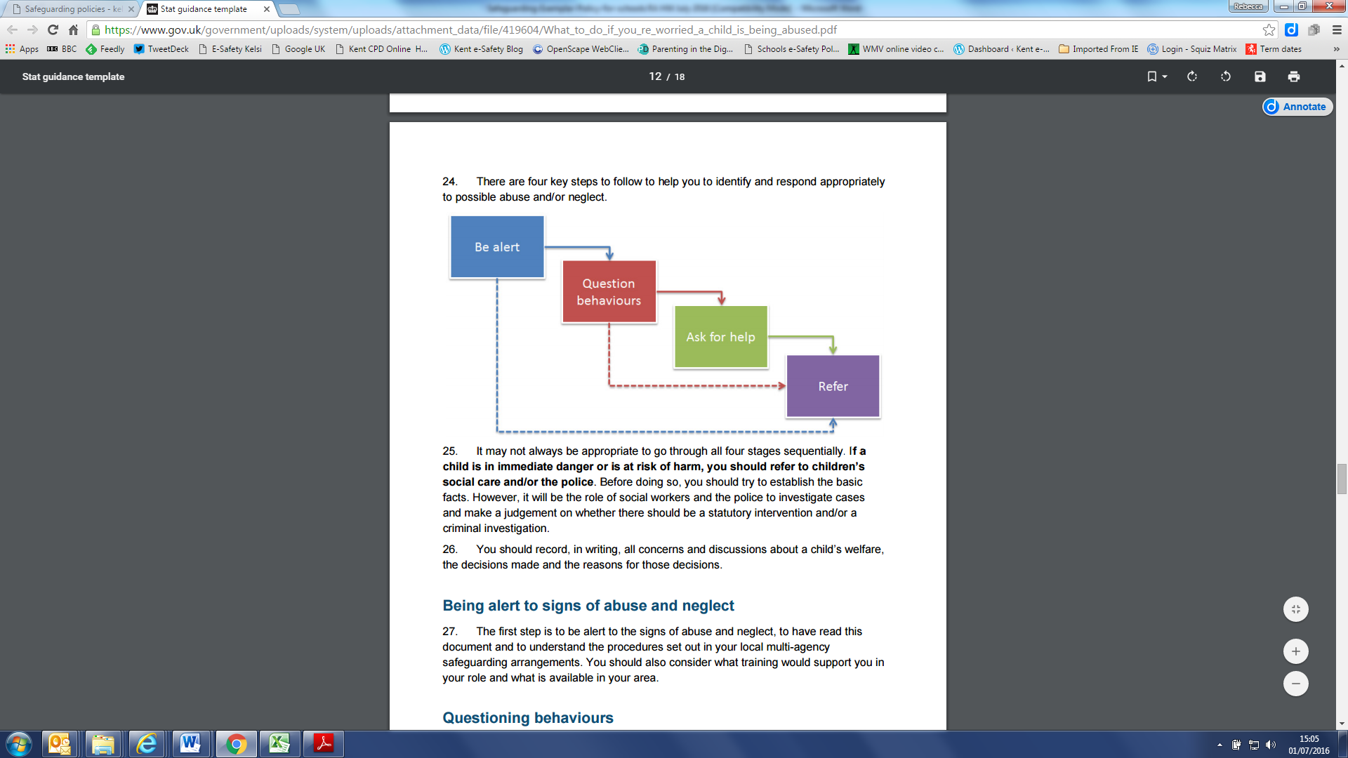
- It may not always be appropriate to go through all four stages sequentially and if a child is in immediate danger or is at risk of harm, a request for support should be made immediately to Children’s Social Work Services and/or the police.

The role of the school in situations where there are child protection concerns is NOT to investigate but to recognise and refer.
- The DSL may seek advice or guidance from Area Education Safeguarding Advisor from the Education Safeguarding Service before making a decision regarding next steps. They may also seek advice or guidance from a social worker at the Front Door service.

- All members of staff are made aware of the internal and local early help support services. Where a child is being offered or receiving early help support, staff will be supported to understand their role in any early help assessment or intervention. This includes identifying emerging problems, liaising with other professionals, and in some cases acting as the lead practitioner.

- The DSL will keep all early help cases under constant review and consideration will be given to a request for support to the Front Door if the situation does not appear to be improving or is getting worse.

- All staff are aware of the process for making request for support referrals for statutory assessments under the Children Act 1989, along with the role they might be expected to play in such assessments.

- In all but the most exceptional circumstances, parents /carers will be made aware of the concerns for their child at the earliest possible stage. In the event of a request for support to the Front Door being necessary, parents/carers will be informed and consent to this will be sought in line with guidance provided by KSCB, unless there is a valid reason not to do so, for example if to do so would put a child at risk of harm to would undermine a criminal investigation.

- In the absence of the availability of the DSL to discuss an immediate and urgent concern, staff can seek advice from the Deputy DSL. They may also seek advice from the Education Safeguarding Service or via consultation with a social worker from the Front Door. If anyone other than the DSL makes a referral to external services, then they will inform the DSL as soon as possible.

- On occasion, staff may pass information about a child to the DSL but remain anxious about action subsequently taken. Staff should feel able to check the progress of a case with the DSL so that they can reassure themselves the child is safe and their welfare is being considered. If following this process, the staff member remains concerned it is the responsibility of that staff member to follow the school’s escalation process.

- If a child’s situation does not appear to be improving, then the DSL (or the person that made the request for support) will consider re-referral. Professional disagreements (escalation) will be responded to in line with the KSCB procedures and DSLs may request support via the Education Safeguarding Service.

- Record Keeping
- Staff will record any welfare concern that they have about a child on the school’s safeguarding incident/concern form (with a body map if injuries have been observed) and pass them without delay to the DSL. Records will be completed as soon as possible after the incident/event, using the child’s words and will be electronically signed and dated by the member of staff. If there is an immediate concern the member of staff should consult with a DSL as this needs to take priority.
- All safeguarding concerns, discussions and decisions (and justifications for those decisions) will be recorded in writing. If members of staff are in any doubt about recording requirements, they should discuss their concerns with DSL.
- Incident/Welfare concern forms are all kept on the Safeguard My School Tool https://edukeyapp.com/account/login

- Safeguarding records are kept for individual children and are maintained separately from all other records relating to the child in the school. Safeguarding records are kept in accordance with data protection legislation and are retained centrally and securely by the DSL. Safeguarding records are shared with staff on a ‘need to know’ basis only.

- All safeguarding records will be transferred in accordance with data protection legislation to the child’s subsequent school/setting, under confidential and separate cover. These will be given to the new DSL and a receipt of delivery will be obtained.

- Detailed guidance on Record Keeping is found in a separate document “Guidelines for Safeguarding Record Keeping in Schools”.

- The Executive Headteacher will be kept informed of any significant issues by the DSL.

- Multi-agency Working
- Ramsgate Arts Primary School recognises and is committed to its responsibility to work with other professionals and agencies in line with statutory guidance (WTTSC 2018)
Schools are not the investigating agency when there are child protection concerns.We will however contribute to the investigation and assessment processes as required. Ramsgate Arts Primary School recognises the importance of multi-agency working and will support attendance at relevant safeguarding meetings, including Child Protection Conferences, Core Groups, Strategy Meetings, Child in Need meetings or other early help multi-agency meetings.
- The School Leadership Team and DSL will work to establish strong and co-operative relationships with relevant professionals in other agencies.

- Confidentiality and Information Sharing
- Ramsgate Arts Primary School recognises that all matters relating to child protection are confidential. The Head of School or DSL will only disclose information about a pupil to other members of staff on a ‘need to know’ basis.
- All members of staff must be aware that whilst they have duties to keep any information confidential, they also have a professional responsibility to share information with other agencies to safeguard children.
- All staff must be aware that they cannot promise a child to keep secrets which might compromise the child’s safety or wellbeing.
- DfE Guidance on Information Sharing (July 2018) provides further detail. This is available in the school staff room and on Sharepoint (Trust Resources – Policies)

- Complaints
- The school has a Complaints Procedure available to parents, pupils and members of staff and visitors who wish to report concerns. This can be found online here: http://app.keysurvey.co.uk/f/1123913/1411/

- All reported concerns will be taken seriously and considered within the relevant and appropriate process. Anything that constitutes an allegation against a member of staff or volunteer will be dealt with under the specific Procedures for Managing Allegations against Staff policy. This can be found in the staffroom and also on Sharepoint (Trust Resources – Policies)

- Staff Induction, Awareness and Training

- All members of staff have been provided with a copy of Part One of “Keeping Children Safe in Education” (2019) which covers Safeguarding information for all staff. School leaders will read the entire document. School leaders and all members of staff who work directly with children will access Annex A within Keeping Children Safe in Education 2019. Members of staff have signed to confirm that they have read and understood Part One and Annex A. The single central record details induction safeguarding training. Additional records (annual training, policy updates and monthly checks) are kept electronically by the DSL detailing dates and electronic signatures recording that staff have confirmed that they have completed and understood training and required reading.
- The DSL will ensure that all new staff and volunteers (including temporary staff) are aware of the school’s internal safeguarding processes.

- All staff members (including temporary staff) will receive training to ensure they are aware of a range of safeguarding issues.

- All staff members (including temporary staff) will receive regular safeguarding and child protection updates, at least annually.

- All staff members (including temporary staff) will be made aware of the schools expectations regarding safe and professional practice via the staff Code of Conduct and Acceptable Use Policy.

- The DSL will provide an annual report to the Governing Body detailing safeguarding training undertaken by all staff and will maintain up to date register of who has been trained.

- Although the school has a nominated lead for the governing body (Portia Sharpin) all members of the governing body will access appropriate safeguarding training which covers their specific strategic responsibilities on a regular basis.

- Safe Working Practice

- All members of staff are required to work within clear guidelines in the school’s Code of Conduct.

- Staff should be aware of the school’s Behaviour Management and Physical Intervention Policies, and any physical interventions must be in line with agreed policy and procedures.

- Staff should be particularly aware of the professional risks associated with the use of social media and electronic communication (email, mobile phones, texting, social network sites etc.) and should adhere to the school’s online safety and Acceptable Use policies.

- Staff Supervision and Support

- Any member of staff affected by issues arising from concerns for children’s welfare or safety can seek support from the DSL.

- The induction process will include familiarisation with child protection responsibilities and procedures to be followed if members of staff have any concerns about a child’s safety or welfare.
- The school will provide appropriate supervision and support for all members of staff to ensure that:
  - All staff are competent to carry out their responsibilities for safeguarding and promoting the welfare of children
  - All staff will be supported by the DSL in their safeguarding role.
  - All members of staff have regular reviews of their own practice to ensure they improve over time.
The DSL will also put staff in touch with outside agencies for professional support if they so wish. Staff can also approach organisations such as their Union, the Education Support Partnership or other similar organisations directly.
- The school will ensure that members of staff who are working within the foundation stage are provided with appropriate supervision in accordance with the statutory requirements of Early Years Foundation Stage (EYFS) 2017.

- Safer Recruitment

- Ramsgate Arts Primary School is committed to ensure that develop a safe culture and that all steps are taken to recruit staff and volunteers who are safe to work with our pupils and staff.
- The Governing Body and Leadership Team are responsible for ensuring that the school follows safe recruitment processes outlined within guidance.
- Ramsgate Arts Primary School is responsible for ensuring that the school maintains an accurate Single Central Record (SCR) in line with statutory guidance.
- The Governing Body will ensure that there is at least one of the persons who conducts an interview has completed safer recruitment training.
- We are also committed to supporting the statutory guidance from the Department for Education on the application of the Childcare (Disqualification) Regulations 2009 and related obligations under the Childcare Act 2006 in schools.
- We advise all staff to disclose any reason that may affect their suitability to work with children including convictions, cautions, court orders, cautions, reprimands and warnings.

- Allegations Against Members of Staff and Volunteers

- Ramsgate Arts Primary School recognises that it is possible for staff and volunteers to behave in a way that might cause harm to children and takes seriously any allegation received. Such allegations should be referred immediately to the Head of School or deputy in their absence who will first contact the Local Authority Designated Officer (LADO) to agree further action to be taken in respect of the child and staff member. In the event of allegations of abuse being made against the Head of School then staff are advised that allegations should be reported to the Chair of Governors who will contact the LADO in the first instance.

- All staff and volunteers should feel able to raise concerns about poor or unsafe practice and such concerns will always be taken seriously by the senior leadership team.

- All members of staff are made aware of the school’s Whistleblowing procedure and that it is a disciplinary offence not to report concerns about the conduct of a colleague that could place a child at risk. Staff can also access the NSPCC whistleblowing helpline if they do not feel able to raise concerns regarding child protection failures internally. Staff can call: 0800 028 0285 (8:00 AM to 8:00 PM Monday to Friday) or email: help@nspcc.org.uk

- Ramsgate Arts Primary School has a legal duty to refer to the Disclosure and Barring Service (DBS) anyone who has harmed, or poses a risk of harm, to a child, or if there is reason to believe the member of staff has committed one of a number of listed offences, and who has been removed from working (paid or unpaid) in regulated activity, or would have been removed had they not left. The DBS will consider whether to bar the person. If these circumstances arise in relation to a member of staff at our school, a referral will be made as soon as possible after the resignation or removal of the individual in accordance with advice from the LADO and/or Schools Personnel Service.

When in doubt – consult

- Safeguarding Children with Special Educational Needs and Disabilities

- Ramsgate Arts Primary School acknowledges that children with special educational needs (SEN) and disabilities can face additional safeguarding challenges as they may have an impaired capacity to resist or avoid abuse.

- Ramsgate Arts Primary School will ensure that children with SEN and disabilities, specifically those with communication difficulties will be supported to ensure that their voice is heard and acted upon.

- Members of staff are encouraged to be aware that children with SEN and disabilities can be disproportionally impacted by safeguarding concerns such as bullying. All members of staff will be encouraged to appropriately explore possible indicators of abuse such as behaviour/mood change or injuries and not to assume that they are related to the child’s disability and be aware that children with SEN and disabilities may not always outwardly display indicators of abuse.

- Peer on Peer Abuse

- All members of staff at Ramsgate Arts Primary School recognise that children are capable of abusing their peers. Peer on peer abuse can take many forms, including but not limited to, bullying, cyberbullying, gender-based abuse, hazing (initiation type violence), sexually harmful behaviour, violence and ‘sexting’. Staff and leadership are to be mindful that some potential issues may be affected by gender, age, ability and culture of those involved.
- Ramsgate Arts Primary School believes that abuse is abuse and it will never be tolerated.
- ‘Upskirting’ is a criminal offence and will not be tolerated. It typically involves someone taking a photograph under a person’s clothes without them knowing, with the intention of viewing their genitals or buttocks to obtain sexual gratification, or cause the victim humiliation, distress or alarm.
- ‘Sexting’ (Youth Produced Sexual Images) will not be tolerated. The school will respond to cases of ‘sexting’ in line with UKCCIS “Sexting in Schools and Colleges” guidance and in line with Kent Safeguarding Children Multi-agency Partnership (KSCMP) guidance.

- Gangs, County Lines, Violent Crime and Exploitation

- Ramsgate Arts Primary School recognises the impact of gangs, county lines, violent crime and exploitation. It is recognised that the initial response to child victims is important and that staff will take any allegation seriously and work in ways that support children and keep them safe.
- All staff have been trained and recognise the need to be vigilant for the signs that may include, but not exclusively:
  - Unexplained gifts/new possessions – these can indicate children have been approached by/involved with individuals associated with criminal networks/gangs.
  - Increased absence from school.
  - Change in friendships/relationships with others/groups.
  - Significant decline in performance.
  - Signs of self-harm/significant change in wellbeing.
  - Signs of assault/unexplained injuries.

- Online Safety

- It is recognised by Ramsgate Arts Primary School that the use of technology presents challenges and risks to children and adults both inside and outside of school.
- The DSL has overall responsibility for online safeguarding within the school.
- Ramsgate Arts Primary School identifies that the issues can be broadly categorised into three areas of risk:
- content: being exposed to illegal, inappropriate or harmful material
- contact: being subjected to harmful online interaction with other users
- conduct: personal online behaviour that increases the likelihood of, or causes, harm.

- The DSL and leadership team have read annex C regarding Online Safety within ‘Keeping Children Safe in Education’ 2019.

- Ramsgate Arts Primary School recognises the specific risks that can be posed by mobile phones and cameras and in accordance with KCSIE 2019 and EYFS 2017 has appropriate policies in place that are shared and understood by all members of the school community. Further information reading the specific approaches relating to this can be found in the schools Online Safety Policy, Acceptable Use Policy and Image Use Policy which can be found in the staffroom and on Sharepoint (Trust Resources – Policies and also in ‘Safeguarding Forms’)

- Ramsgate Arts Primary School will ensure that appropriate filtering and monitoring systems are in place when pupils and staff access school systems and internet provision.

- Ramsgate Arts Primary School acknowledges that whilst filtering and monitoring is an important part of schools’ online safety responsibilities, it is only one part of our approach to online safety. Pupils and adults may have access to systems external to the school control such as mobile phones and other internet enabled devices and technology and where concerns are identified appropriate action will be taken.

- Ramsgate Arts Primary School will ensure a comprehensive whole school curriculum response is in place to enable all pupils to learn about and manage online risks effectively and will support parents and the wider school community (including all members of staff) to become aware and alert to the need to keep children safe online.

- Curriculum and Staying Safe

- We recognise that schools play an essential role in helping children to understand and identify the parameters of what is appropriate child and adult behaviour; what is ‘safe’; to recognise when they and others close to them are not safe; and how to seek advice and support when they are concerned.

- Our curriculum provides opportunities for increasing self-awareness, self-esteem, social and emotional understanding, assertiveness and decision making so that students have a range of contacts and strategies to ensure their own protection and that of others. Online safety is integrated into the curriculum.

- Our school systems support children to talk to a range of staff. Children will be listened to and heard and their concerns will be taken seriously and acted upon as appropriate.

- The Use of School Premises by Other Organisations

- Where services or activities are provided separately by another body using the school premises, the Head of School and Governing Body will seek written assurance that the organisation concerned has appropriate policies and procedures in place with regard to safeguarding children and child protection and that relevant safeguarding checks have been made in respect of staff and volunteers.

- If this assurance is not achieved, then an application to use premises will be refused.

- Security

- All members of staff have a responsibility for maintaining awareness of buildings and grounds security and for reporting concerns that may come to light.

- Appropriate checks will be undertaken in respect of visitors and volunteers coming into school as outlined within guidance. Visitors will be expected to sign in and out via the office visitors log and to display a visitors badge whilst on school site. Any individual who is not known or identifiable should be challenged for clarification and reassurance.

- The school will not accept the behaviour of any individual (parent or other) that threatens school security or leads others (child or adult) to feel unsafe. Such behaviour will be treated as a serious concern and may result in a decision to refuse access for that individual to the school site.

- Monitoring and Review

- All school staff (including temporary staff and volunteers) will have access to a copy of this policy. The policy will also be available to parents/carers.

- The policy forms part of our school development plan and will be reviewed annually.

- Local Support

- All members of staff at Ramsgate Arts Primary School are made aware of local support available.
  - Contact details for Area Safeguarding Advisor (Education Safeguarding Service)
    - www.kelsi.org.uk/support-for-children-and-young-people/child-protection-and-safeguarding/safeguarding-contacts
Claire Ray Head of Service 03000 415788
Thanet Office - 03000 418503

  - Contact details for Online Safety in the Education Safeguarding Service
    - Rebecca Avery, Education Safeguarding Advisor (Online Protection):
    - Ashley Assiter, Online Safety Development Officer
    - 03000 415797
    - esafetyofficer@kent.gov.uk (non-urgent issues only)

  - Contact details for the LADO
    - Telephone: 03000 410888
    - Email: kentchildrenslado@kent.gov.uk

  - Childrens Social Work Services
    - Front door: 03000 411111
    - Out of Hours Number: 03000 419191

  - Kent Police
    - 101 (or 999 if there is an immediate risk of harm)

  - Kent Safeguarding Children Multi-agency Partnership (KSCMP)
    - kscmp@kent.gov.uk
    - 03000 421126

- National Support

Support for staff
- Education Support Partnership: www.educationsupportpartnership.org.uk
- Professional Online Safety Helpline: www.saferinternet.org.uk/helpline

Support for Pupils
- NSPCC: www.nspcc.org.uk
- ChildLine: www.childline.org.uk
- Papyrus: www.papyrus-uk.org
- Young Minds: www.youngminds.org.uk
- The Mix: www.themix.org.uk

Support for adults
- Family Lives: www.familylives.org.uk
- Crime Stoppers: www.crimestoppers-uk.org
- Victim Support: www.victimsupport.org.uk
- Kidscape: www.kidscape.org.uk
- The Samaritans: www.samaritans.org
- Mind: www.mind.org.uk
- NAPAC (National Association for People Abused in Childhood): napac.org.uk
- MOSAC: www.mosac.org.uk
- Action Fraud: www.actionfraud.police.uk

Support for Learning Disabilities
- Respond: www.respond.org.uk
- Mencap: www.mencap.org.uk

Domestic Abuse
- Refuge: www.refuge.org.uk
- Women’s Aid: www.womensaid.org.uk
- Men’s Advice Line: www.mensadviceline.org.uk
- Mankind: www.mankindcounselling.org.uk
- Domestic abuse services: www.domesticabuseservices.org.uk

Honour based Violence
- Forced Marriage Unit: https://www.gov.uk/guidance/forced-marriage

Sexual Abuse and CSE
- Lucy Faithfull Foundation: www.lucyfaithfull.org.uk
- Stop it Now!: www.stopitnow.org.uk
- Parents Protect: www.parentsprotect.co.uk
- CEOP: www.ceop.police.uk
- Marie Collins Foundation: www.mariecollinsfoundation.org.uk
- Internet Watch Foundation (IWF): www.iwf.org.uk

Online Safety
- Childnet International: www.childnet.com
- UK Safer Internet Centre: www.saferinternet.org.uk
- Parents Info: www.parentinfo.org
- Internet Matters: www.internetmatters.org
- Net Aware: www.net-aware.org.uk
- ParentPort: www.parentport.org.uk
- Get safe Online: www.getsafeonline.org

Radicalisation and hate
- Educate against Hate: www.educateagainsthate.com
- Counter Terrorism Internet Referral Unit: www.gov.uk/report-terrorism
- True Vision: www.report-it.org.uk

