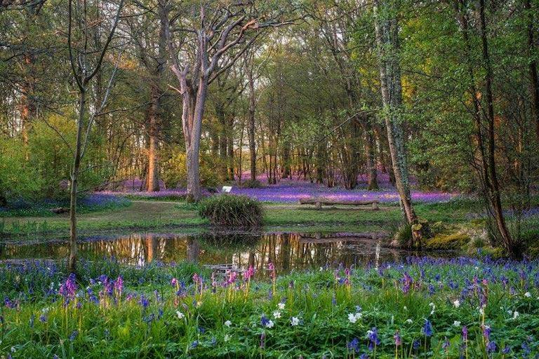
We entered the wood through the gate. The ground was covered in beautiful bluebells as far as we could see. The wood was lush with bright green ferns and the air smelt damp but fresh. Tall trees of different colours made pretty shadows with their leaves. Between the trees the bright sun burst through seemed to light up the wood with fairy lights. It was so magical! We could hear the birds tweeting in the trees and the rustle of creatures. I felt a dragon fly buzz against my cheek and spotted dew twinkling on a delicate spiders web.
We started to walk along the squelchy muddy path and the long grasses brushed our legs. Soon the path ended so we crunched through the bluebells and headed for a bridge, our hearts pounding with excitement. Chrissy and I raced across the bridge and suddenly saw the most beautiful pond rippling with life and covered in round green lily pads. Elegant grasses and ferns swayed around the edge of the pond and beckoned us closer.

