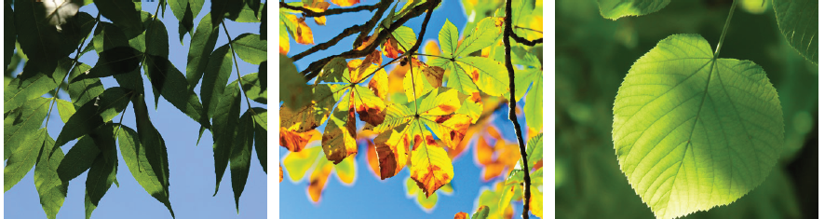
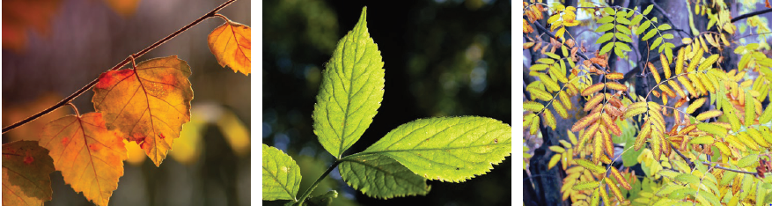
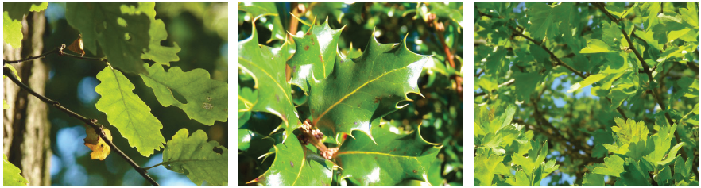
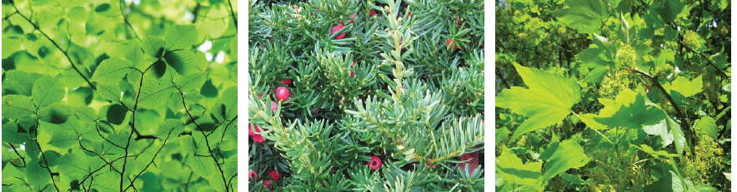
Rowan
Birch
Elder
Oak
Holly
Hawthorn
Beech
Yew
Sycamore
Ash
Horse chestnut
Lime

Deciduous

Evergreen

