I am learning to describe turns
quarter turn half turn
three quarter turn full turn
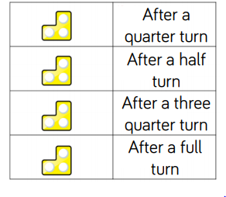
Can you draw what the shape will look like once it has turned:

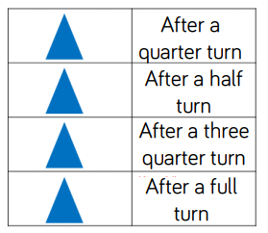
Can you draw what the shape will look like once it has turned:

REASONING
I am learning to describe turns
quarter turn half turn
three quarter turn full turn
Follow the arrows to work out what turns have been made by each shape.
Are these statements correct? Explain how you know.



