Think about your pet - what kind of habitat does it need?
- Does it need an area with water?
- Do you need heat?
- What kind of light will it need?
- What plants (if any) will you need?
- How big does the home need to be? (how big could your pet grow)
- Where will it sleep/rest/exercise
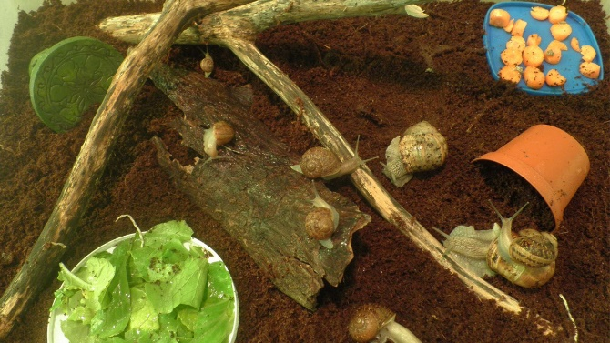
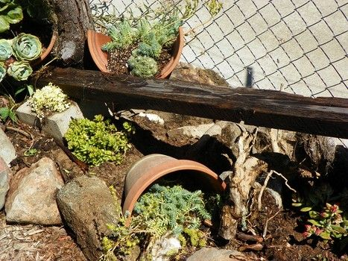
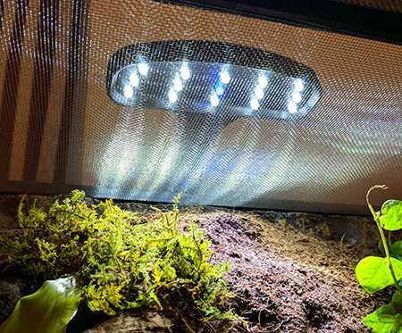
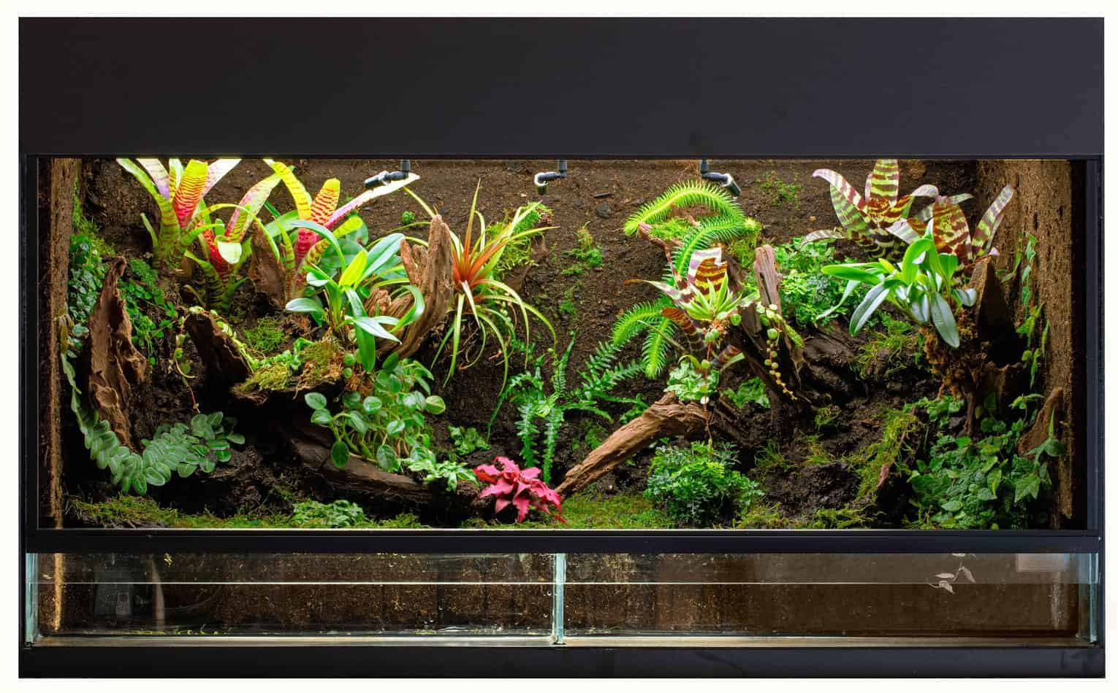
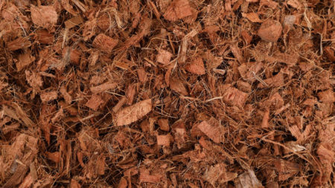
- What materials will it need – wood/rock/sand/damp moss/gravel etc
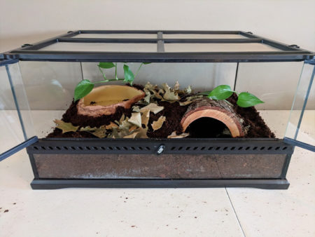
How to make pet habitat websites:
https://pethelpful.com/reptiles-amphibians/How-to-Make-a-House-for-Your-Pet-Lizard
http://www.kuddly.co/living/how-to-pick-the-perfect-habitat-for-pet/
https://www.instructables.com/id/How-to-Set-Up-a-Reptile-Terrarium/
https://www.petsmart.com/learning-center/reptile-care/caring-for-your-snake/A0042.html

