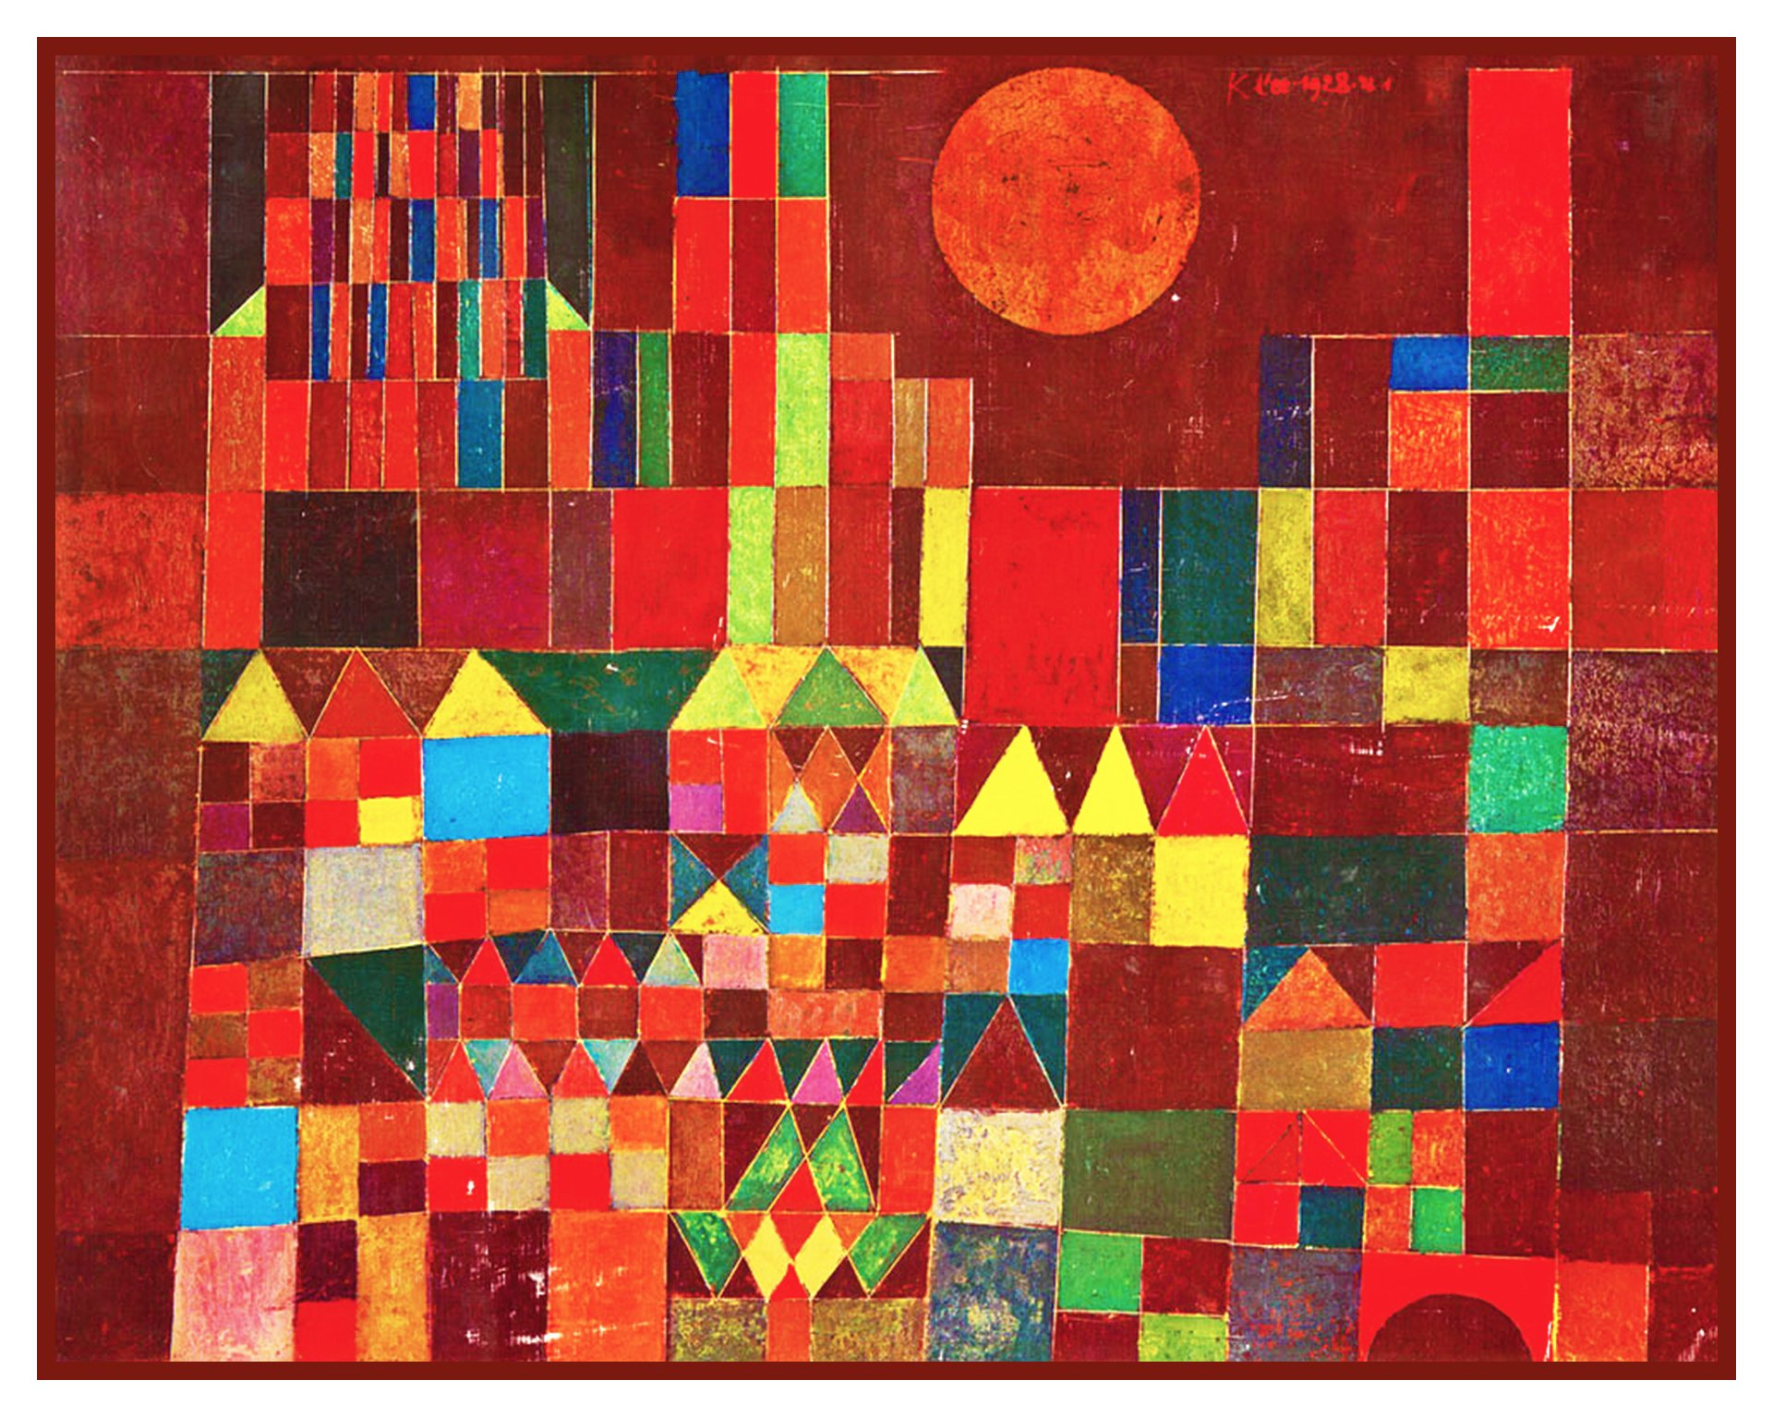
Castle and Sun by Paul Klee, 1928

