- There are 3 tenths in 133.32. True or false? | 2. a) What is 100 more than 4919?  b) What is 100 less than 8038?
3. Solve  -7 + 4 =  1 – 3 =  -5 - 4 = | 4. Put in the appropriate sign  37.4 [ ] 37 and 4/10  25.07 [ ] 25.70  5 [ ] -410
5. Round to the nearest 100:  26 –  153 –  211 - | 6. SOLVE:  XI + IV =  XVIII + CXI =  MCCXXIV =

Date:____________

.

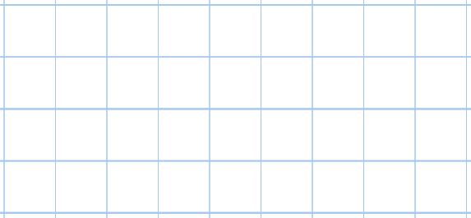  7. Solve 5200 - 3979 | 8. Solve 1937 + 8876
9. Give three fractions that are EQUIVALENT to ½ .
10. Solve (2 x 7) + (7 + 3) + (-2 + 4)

Year 4

- Solve 1477+9709 | 12. How many tenths make up one whole?
13. 3 x 4 x 5 = | 15. All, some or none?  All multiples of 4 are even.  Fractions can be more than 1.  Multiples of 3 can be divided by 2 with no remainders.
15. Round to the nearest 10:  16 –  73 –  859 - | 16. Convert these time to am times.  23:04  15:24  19:22
Date:____________

17. Solve £34.84 x 5 |   18. Label the points on the compass.
19. Using the bus stop method, what is 2972 divided by 4?
20. Find 1/2 of 28 and show ALL working.

Year 4

