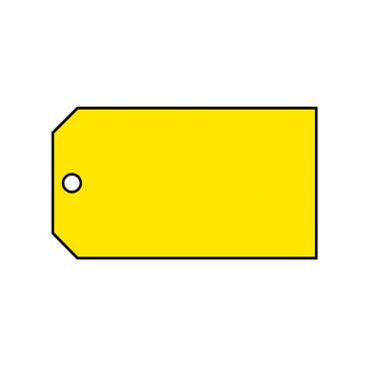
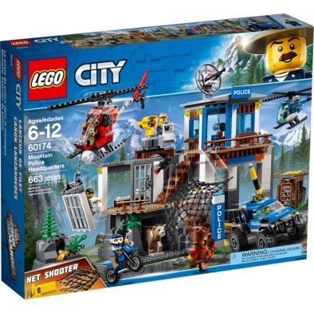
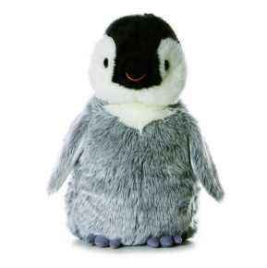
- How much will it cost to buy
- Shin pads and a pot of slime?
- An LOL doll and a pencil case?
- A badge and a lollypop?

2. How much will it cost to buy…
a) A PS4 game and a penguin?
b) Slime, a pencil case and a penguin?

3. a) What is the most I can spend if I buy 3 items?
3. b) What is the least I can spend if I buy 4 items?

4. What objects could I buy that would have a total closest to £20?

Extension:
Write your own word problems and solve them!
Penguin
£9.99
Lego set
£75.50
Lego set
£75.50
Lego set
£75.50



Lollypop
20p
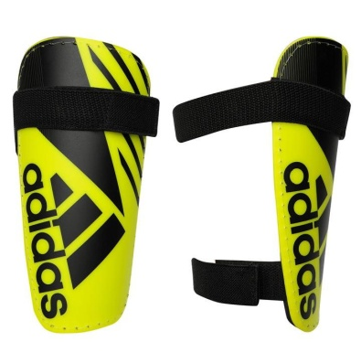
LOL doll
£10.50
Slime
£4
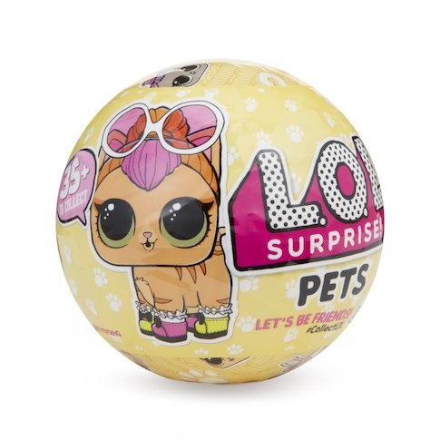
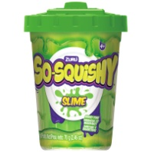
Shin pads
£15

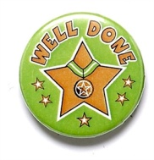
Badge
£0.60
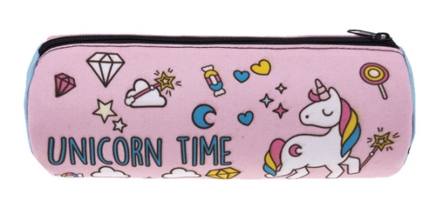

PS4 game
£52.40
Pencil case
£7.49

