
ONE chilli

How much change if I buy...
- A Choco Bar with 30p?
b) A toffee Tub with 50p?
c) A Fizz Buzz with 50p?
d) A Fruit Sherbert with £1?
e) A Rock Bar with £1?
f) A Toffee Tub with £2?

CHALLENGE:
g) 2 Nutty Munches with £1?

h) A Nibbles and a Krunchie with £2?

TWO chilli

How much change if I buy...
a) sweets with £1?
b) a rubber with £2?
c) Buckaroo with £10?
d) colour pens with £10?
e) a fidget cube with £5?
f) a Nerf gun with £20?

CHALLENGE:
g) a Hatchimal and sweets with £10?

h) Coloured pens and a rubber with £20?
THREE chilli
How much change if I buy...
a) a videogame with £50?
b) colour pens with a £20?

CHALLENGE:

c) 2 Hatchimals with £20?
d) 3 bags of sweets with £2?
e) a fidget cube and a rubber with £5?

Extension:
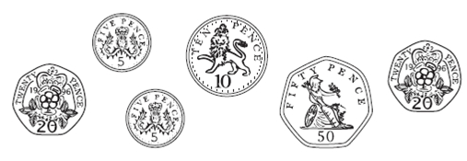
a) I had £2. I spent this much money:

How much have I got left?
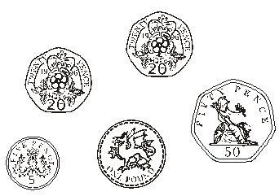
b) I had £5. I spent this much money:

How much have I got left?

