
ONE chilli

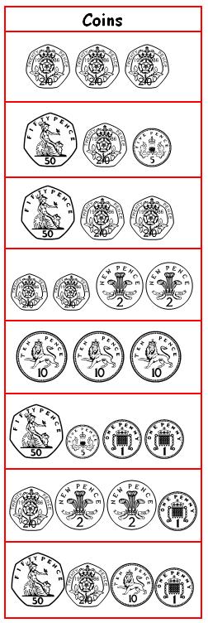
Calculate the change from £1 if I spend:
a)

b)
c)

d)
e)

f)
g)

h)

TWO chilli

How much change if I spend...
a) 79p and pay with £1?
b) £1.60p and pay with £2?
c) £2.95 and pay with £5?
d) 85p and pay with £5?
e) £7.20 and pay with £10?
f) £4.38 and pay with £10?

CHALLENGE:
g) £2.50 on a notebook and £75p on a pencil and pay with £5?
h) £6.50 on a mug and £3.99 on a cuddly toy and pay with £20?
THREE chilli
How much change if I spend...
a) £4.35 and pay with £10?
b) 64p and pay with £5?

CHALLENGE:
c) £4 on a toy animal and £2.75 on sweets and pay with £10?
d) 95p on sweets, 75p on a pencil and £1.50 on a postcard and pay with £5?
e) £3 on a card game, £0.89p on sweets and 649 pence on a picture and paid with £20?

Extension:
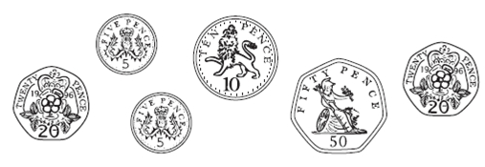
a) I had £5. I spent this much.

What is the fewest number of coins I could get as change? Prove it!

