- There are 3 hundreds in 15,732. T or F ? | 2. a) What is 10 less than 2367?  b) What is 100 less than 8608?
3. Solve  _______ = 210 - 1  -4 + 4 = _______  -7 + 8 = _______  -10 + 1 = _________ | 4. Put in the appropriate sign  3724 [ ] 3742  45.8 [ ] 458  0 [ ] -4
5. Round to the nearest 10:  16 –  53 –  618 - | 6. SOLVE:  XVI + X =  XXVI + IX =  MCCXXIV =
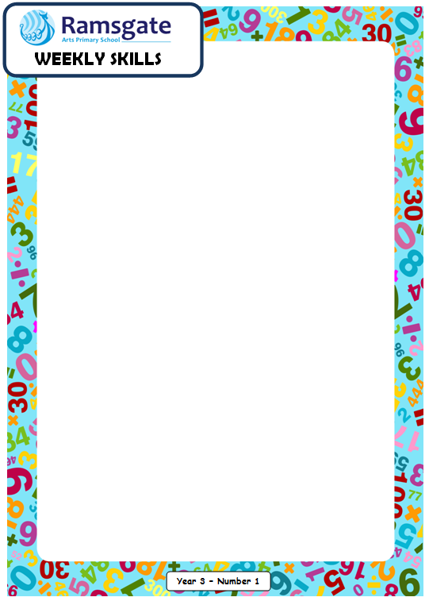
Year 4
Date:____________

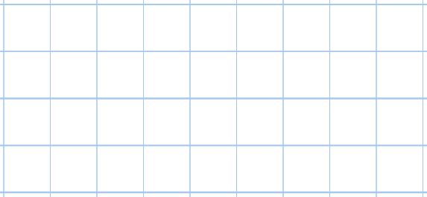  7. Solve 8000 - 4375 | 8. Solve 4353 + 1816
9. Can this be a number in Roman numerals? If so, what number? If not, why not?
CCCCXXIX =
10. Solve (6 X 2) + (3 X 4) + (-2 + 9)

Date:____________

- Solve 937 X 3 | 12. SHOW three sevenths add two sevenths as a number sentence and solve.
13. What does ‘equivalent’ mean? | 15.  8 lots of 10 [ ] 100 lots of 0.8
15. Solve £79.18 X 5 | 16. Convert these time to pm times.  07:24  00:39  09:52
Year 4
17. Using the bus stop method, what is 6872 divided by 4? | 18. How many minutes are there in 1 and a quarter hours?
19. From which country did the number 0 come from?

Year 4

