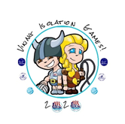

Team RAPS,

The pictures and videos that you are sending in are fabulous, thank you.

This week’s challenges have a twist. The Olympics would have been happening this year in Tokyo but, due to the current circumstances, they have been postponed to next year. All challenges from now on will be Olympic events.

You will be an Olympian! Choose your country and participate in the event using your imagination! I cannot wait for these pictures and videos

The Olympic Challenges are:
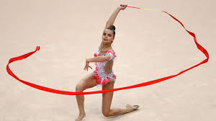
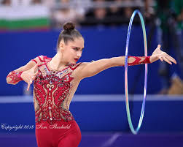
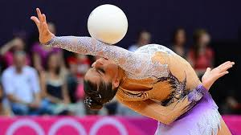
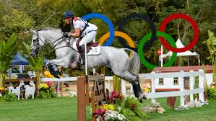
Rhythmic Gymnastics

https://www.youtube.com/watch?v=MBVCjW7EHWs

Equestrian

https://tokyo2020.org/en/news/videos/one-minute-one-sport-equestrian
Have a look at the links to give you some ideas!

Good luck!

Please continue to send them to jenny.horrigan@ramsgateartsprimaryschool.co.uk

Mrs Horrigan

