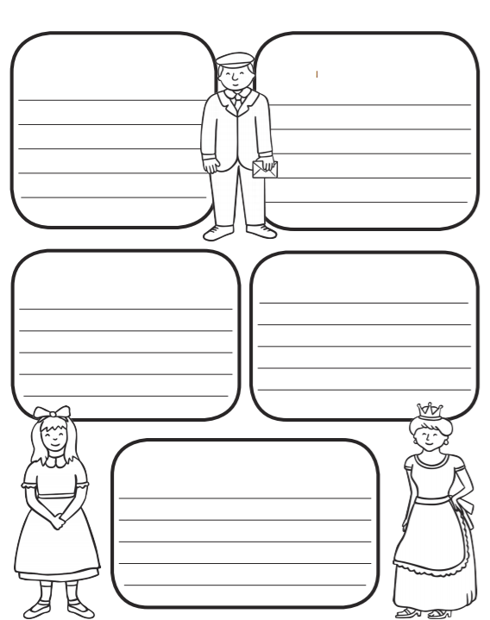
Letter
Characters
Characters
Characters
Setting
ME: I can plan a new page for the story

