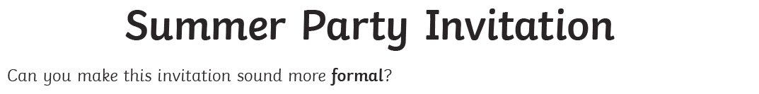
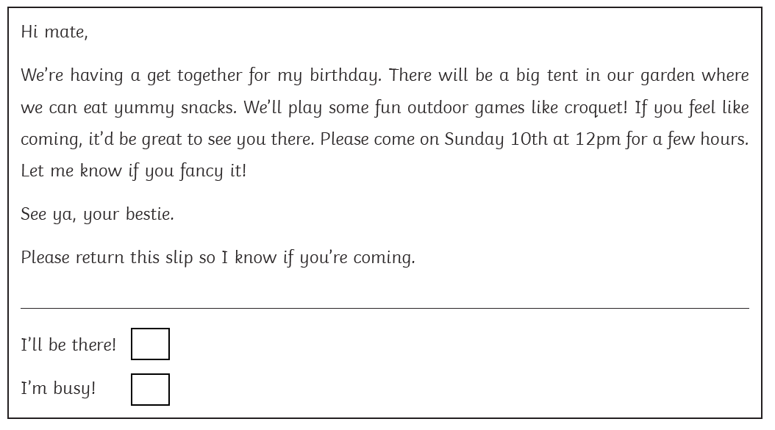

Key vocab

- Cordially invited
- Delicious cuisine
- Social gathering
- Large marquee
- We will participate in
- RSVP

