Complete these questions:
1. Find $\frac{1}{3}$ of 18 2. Find $\frac{2}{3}$ of 24

3. Find $\frac{2}{5}$ of 20 4. Find $\frac{3}{4}$ of 32

EXPLAIN the mistakes.
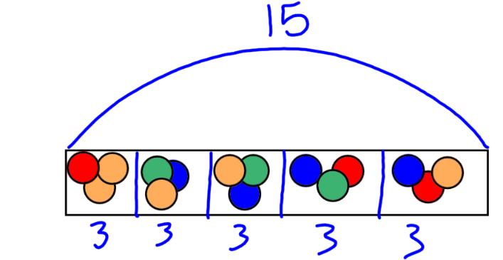
5. Find $\frac{1}{3}$ of 15
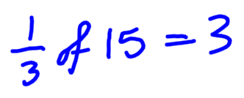

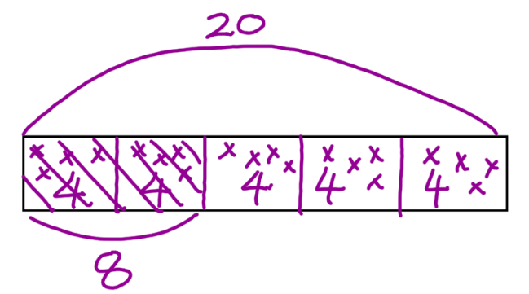
6. Find $\frac{3}{5}$ of 30
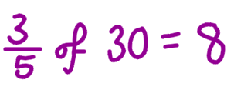


7. Trevor wants to buy a computer game.

It was £45 but there is a sale on and Trevor
gets $\frac{1}{5}$ off.

HOW much will he PAY?

