Term 3 Art Competition

Ramsgate
Arts Primary School
Batman Art
Dear Artists,
I hope you enjoyed the assembly given by Mrs Walton on Batman Art last Thursday. This term’s competition is to create a piece of art inspired by the Batman universe, using ANY medium of your choice. You could use pen, pastels, coloured pencils, Lego, paint on canvas, origami or collage...there is no limit. You might even choose to make a make a 3D model of Gotham City, with a glowing batlight! Alternatively, you could simply do a detailed sketch of your favourite Batman villain. The decision is yours. Whatever you choose to do it must relate in some way to the legendary caped crusader!
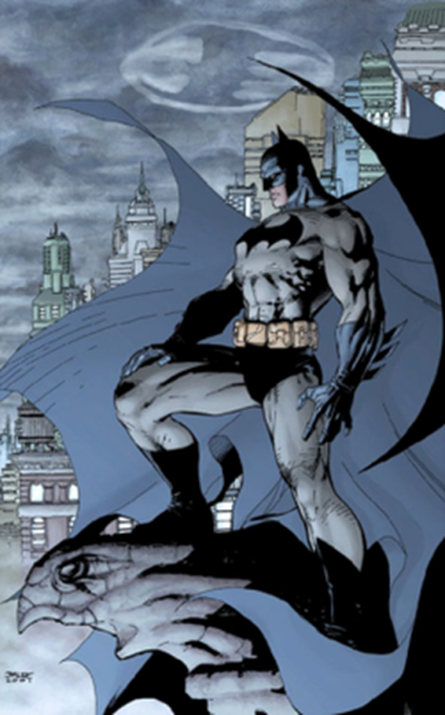
Your creation can be ANY size. Please make sure all entries are CLEARLY labelled with your name & class.
All entries need to be given to me by Wednesday 13th February 2018. Winners will be announced at the beginning of term 3
There will be a certificate for all entries and cool prizes for the winners.
Many thanks for your stunning entries for the Andy Goldsworthy competition. The quality of the entries was very high yet again.
As always, I look forward to being delighted and surprised your brilliant artwork.
Mr Brown
Art Leader

