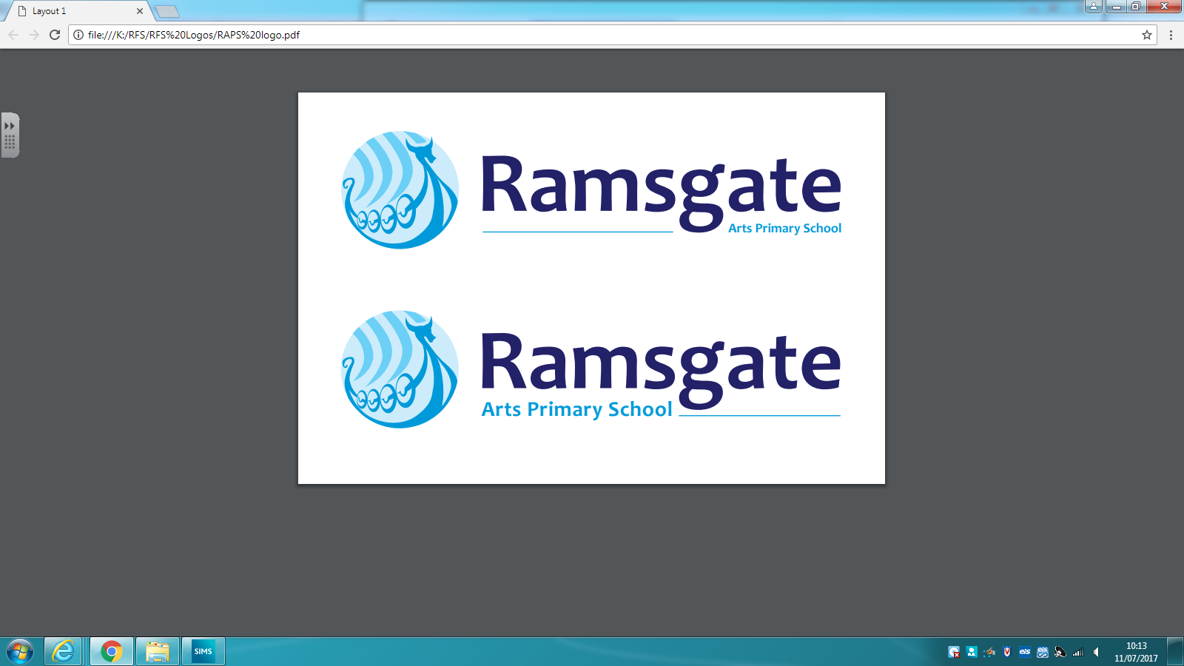

140-144 Newington Road Ramsgate, CT12 6PT

Dear Parents/Carers,
Year 4 and 5 have been invited to a performance of ‘The Sound of Music' on Wednesday 31st of January at Chatham House School.
This will be performed by the students of Chatham and Clarendon School, who want the opportunity to practice before they open to the public.
The performance begins at 12.30 so the children will eat their lunches before leaving. If your child has school dinners a packed lunch will be provided.
The children will be walking so please make sure that they have coats and sensible walking shoes on the day.
We will be back before the end of the school day and will finish at 4.15pm as normal.
Yours Sincerely

Mr Todd & Miss Amin

