Term 4 Art Competition

Ramsgate
Arts Primary School
Andy Warhol
Dear Artists,
I hope you enjoyed the Andy Warhol assembly given by Mrs Walton on Thursday. This term’s competition is to create a piece of art inspired by the work of Andy Warhol, using ANY medium of your choice. For example, you could use pen, pastels, coloured pencils, Lego, paint on canvas or collage. Remember, Andy Warhol used simple blocks of bright colour and repeated imagery.
Your creation can be ANY size. Please make sure all entries are CLEARLY labelled with your name & class.
All entries need to be given to me by Wednesday 28th March 2018. Winners will be announced at the Art assembly in Term 5.
There will be a certificate for all entries and cool prizes for the winners.
A huge thank you to everyone that entered the Batman competition. We had an extremely enthusiastic response to this theme, with some incredibly imaginative pieces of art.
I look forward to seeing your brilliant competition entries.
Mr Brown
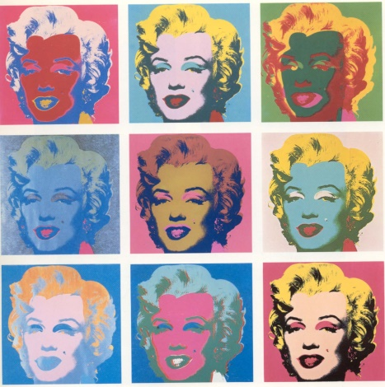
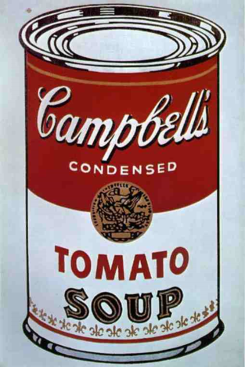
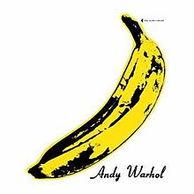
Art Leader

