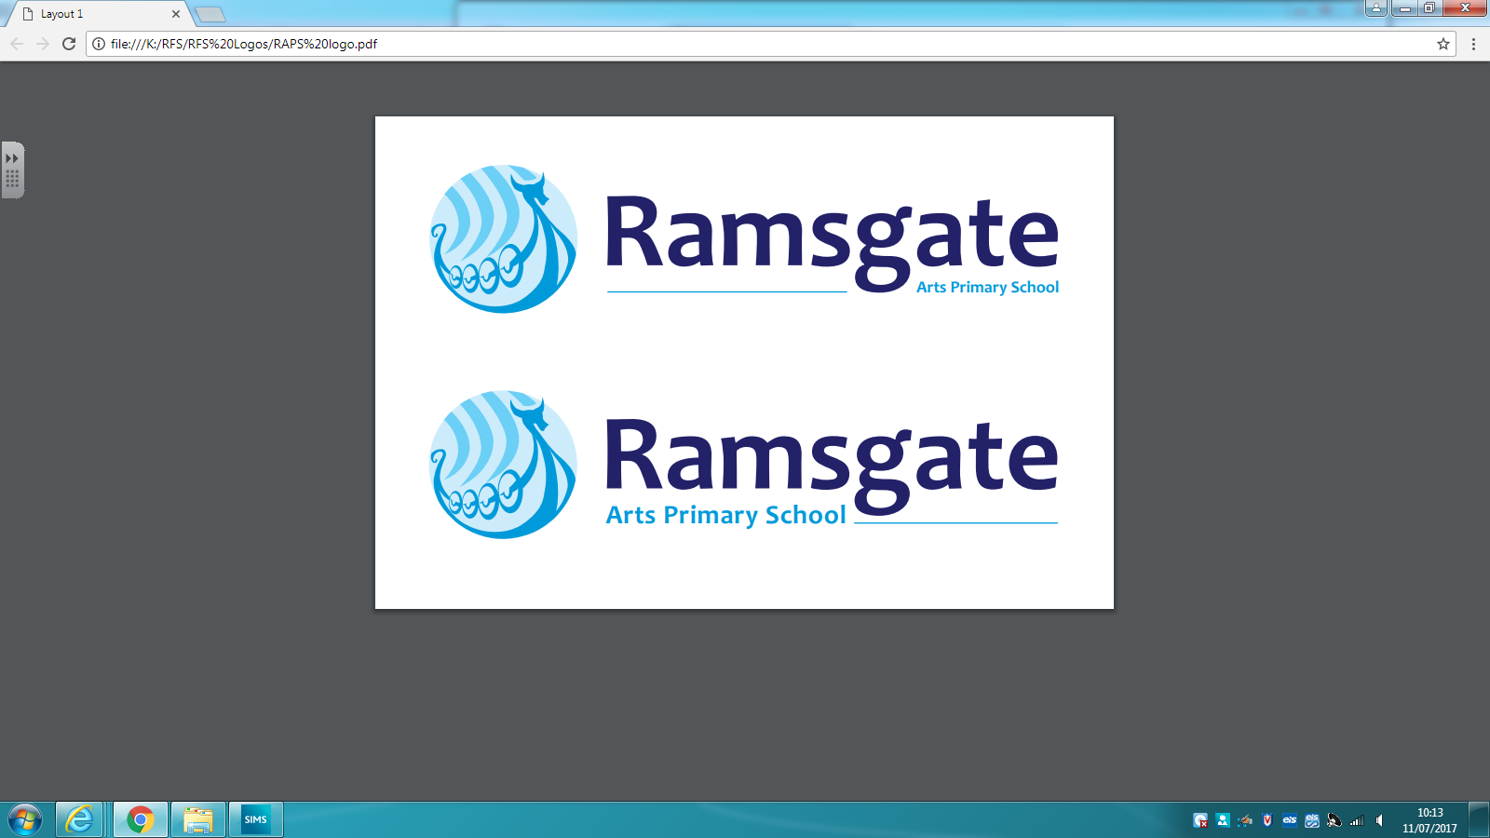

140-144 Newington Road Ramsgate, CT12 6PT
Victorian Christmas Day– Friday 7th December 2018
Dear parent/carer
As part of our learning in topic on the Victorians, year 5 and 6 will be visiting Kent Life Museum on Friday 7th December for a Victorian Christmas day.
The day will consist of 6 workshops which will run from 10.00 am – 2.35pm. We are asking that children wear period clothing to enter into the spirit of the day! Please remember that warm clothes and suitable footwear will be needed. Children will also need to bring a packed lunch and enough drinks for the day (please no fizzy drinks).
We will be travelling by coach and will be arriving back at school around 4pm.
The cost of the trip including the coach is £15 per child.
Please complete the below form and complete your payment online by Friday 30th November.
----------------------------------------------------------------------------------------------------------------
Victorian Christmas Day at Kent Life Museum
I give permission for my son/daughter _______________________________________ to attend the Victorian Christmas Day at Kent Life on 7th December.
Emergency contact: _________________________________
Emergency contact number: ________________________________________________

Signed ___________________________________

