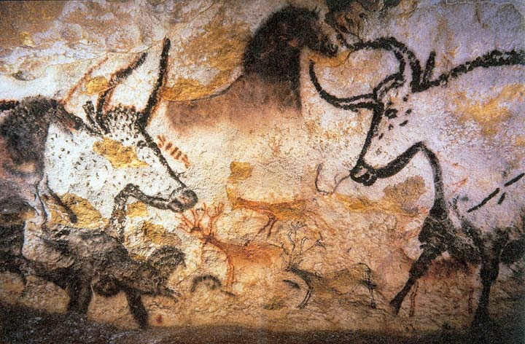
Wednesday 25th April 2018
ENTRY POINT: Settlers and Scavengers

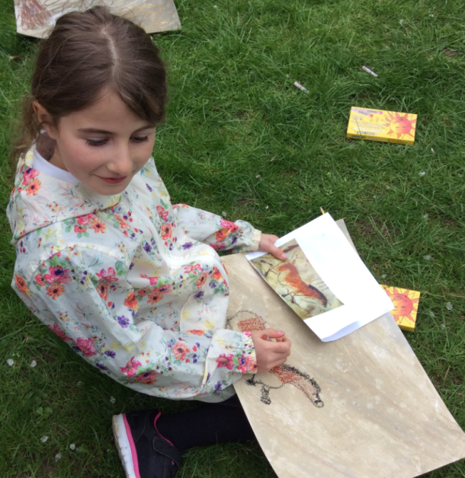
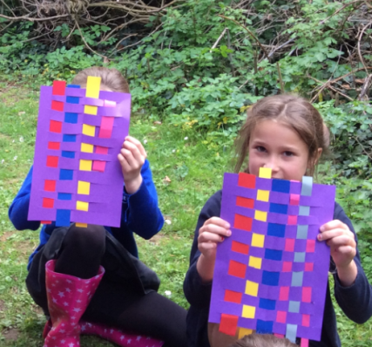
Team Beraet began their new Topic this term which is called “Settlers and Scavengers”. In order to begin thinking about life during the prehistoric periods, we swapped our classroom for a forest school! Here, we immersed ourselves in our environment and started to think about how we would hunt for food, practised weaving, and we even created some cave paintings! Collaborating with each other, we also produced some freeze frames and role played our reactions to problems that we might have encountered whilst living in the Stone Age.


