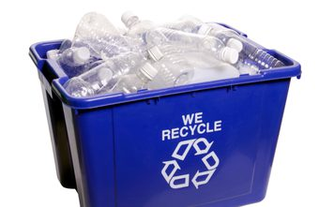



TEAM AMIN: LOVE TO LEARN

Due week beginning: Monday 11th June
Thinking about recycling
Recently, Team Amin have been discussing recycling and why we do it. In preparation for our upcoming Topic, I would like them to research around recycling and to present their findings in an interesting, creative manner. Some of their suggestions from our discussion today include creating a/an:
- Info booklet or poster including questions about learning
- Documentary/video with an interesting voiceover
- Official Powerpoint presentation
- Writing a letter to contact a company to see if they use recycled materials and recording their response
- Piece of artwork made of recycled materials with an explanation of what was used and why
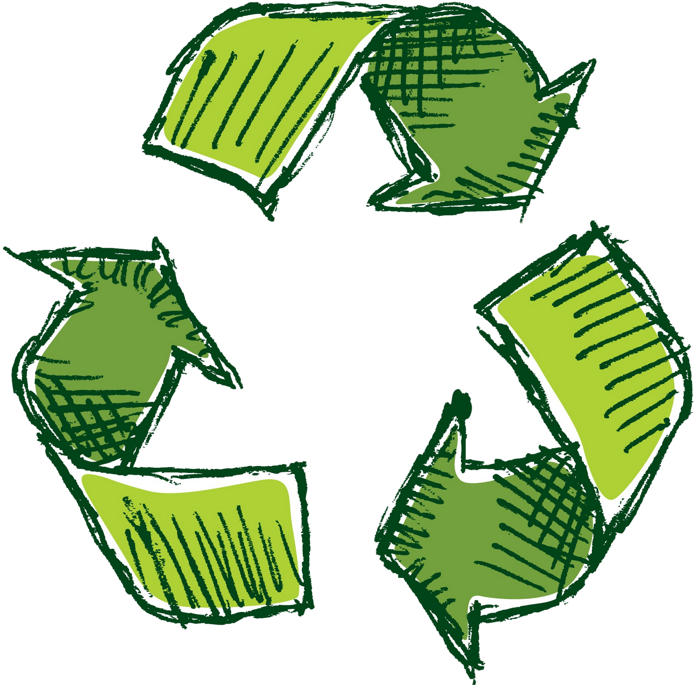
The children are free to decide how they would like to present their research. I hope that it will be creative, colourful and, most importantly, informative.
This L2L needs to be in by Wednesday 13th June.

HAPPY HALF TERM, TEAM AMIN!

